**Benchmarking genome-resolved gut metagenomics on short-, long-read and metaHiC sequencing data**

**Supplementary materials**

Longhao Jia1, Yingjian Wu2, Yanqi Dong1, Jingchao Chen2, Wei-Hua Chen2,3,*, Xing-Ming Zhao1,4,5,6,*

**Affiliations**

1Institute of Science and Technology for Brain-Inspired Intelligence, Fudan University, Shanghai 200433, China.

2Key Laboratory of Molecular Biophysics of the Ministry of Education, Hubei Key Laboratory of Bioinformatics and Molecular-imaging, Center for Artificial Intelligence Biology, Department of Bioinformatics and Systems Biology, College of Life Science and Technology, Huazhong University of Science and Technology, Wuhan 430074, Hubei, China

3Institution of Medical Artificial Intelligence, Binzhou Medical University, Yantai 264003, China

4Key Laboratory of Computational Neuroscience and Brain-Inspired Intelligence, Ministry of Education, Ministry of Education, Shanghai 200433, China

5MOE Frontiers Center for Brain Science, Fudan University, Shanghai 200433, China.

6Zhangjiang Fudan International Innovation Center, Shanghai, China.

* To whom correspondence should be addressed.

**Emails**

Longhao Jia: [19110850010@fudan.edu.cn](mailto:19110850010@fudan.edu.cn)

Yingjian Wu: [d202180734@hust.edu.cn](mailto:d202180734@hust.edu.cn)

Yanqi Dong: [20110850017@fudan.edu.cn](mailto:20110850017@fudan.edu.cn)

Jingchao Chen: [d201980575@hust.edu.com](mailto:d201980575@hust.edu.com)

Wei-Hua Chen: [weihuachen@hust.edu.cn](mailto:weihuachen@hust.edu.cn)

Xing-Ming Zhao: [xmzhao@fudan.edu.cn](mailto:xmzhao@fudan.edu.cn)

## Supplementary methods and results

### Genome-resolved metagenomics

Genome-resolved metagenomics is a method to obtain microbial genomes (metagenome-assembled genomes, MAGs), and then explore taxonomic and functional interpretation at the genome level [1]. The term "Genome-resolved metagenomics" has been used in many surveys [2-4], which involves a series of four steps: (i) preprocessing of the sequencing reads, (ii) de novo metagenome assembly, (iii) genome binning and (iv) taxonomic and functional analysis of the recovered genomes.

### Datasets used for benchmarking

#### GIS20 mock community data

The GIS20 mock community sequencing data was publicly available and downloaded from the European Nucleotide Archive (ENA) under project ID PRJEB29139 (Illumina, PacBio and Nanopore) [5]. The mock community was sequenced with great depth using Illumina HiSeq 2000 (80% strains with >30× coverage), PacBio RS II (55% strains with >5× coverage), and Oxford Nanopore (MinION) (65% species with >5× coverage) platforms. However, only seventeen species have reference genomes; *Pseudomonas putida*, *Neisseria subflava,* and *Eubacterium siraeum* have no publicly available reference genomes (Table S1). Due to the lack of metaHiC sequencing reads in the original GIS20 dataset, sim3Cv.0.2 [6] was used to simulate metaHiC reads based on seventeen reference genomes using parameters -e Sau3AI -m hic –n 4000000. We obtained 40.69 Gb mNGS data, 5.3 Gb PacBio data, 2.45 Gb Nanopore data, and 1.20 Gb simulated metaHiC data.

#### CAMISIM simulation dataset

The 2nd Critical Assessment of Metagenome Interpretation (CAMI II) Toy Human Microbiome Project Dataset produced simulated Illumina and PacBio sequencing data with a 5 Gb total size per sample, which were much lower than our real dataset. We used CAMISIM [7] to simulate three human gastrointestinal tract samples based on CAMI II with 69, 63, and 46 strains respectively (Table S2). The community was simulated with great depth for mNGS (size=50.0 Gb, type=art, fsm=270 bp, fzsd=27 bp), PacBio (size=20 Gb, type=pbsim, fsm=10000 bp, fzsd=3000 bp) and Nanopore (size=30 Gb, type= nanosim, fsm=7700 bp, fzsd=6000 bp). Here fsm was fragments_size_mean, and fzsd was fragment_size_standard_deviation. For each sample, metaHiC reads were generated by sim3Cv.0.2 [6] using parameters -e Sau3AI -m hic -n 64000000. We obtained 50.00 Gb mNGS data, 20.00 Gb PacBio data, 30.00 Gb Nanopore data, and 19.20 Gb metaHiC data for each of the three simulated stool samples.

#### Sample preparation

This study was approved by the Human Ethics Committee of the Tongji Medical College of Huazhong University of Science and Technology (No, S1241). Three human feces samples were obtained from three healthy volunteers recruited in Wuhan, China.Samples were immediately cooled with dry ice and then transferred to a -80°C freezer within five hours. Briefly, total genomic DNA was extracted from 150mg of feces using Stool DNA Kit (Omega, D4015) according to the manufacturer's instructions. The purified genomic DNAs were quality‐checked by Agarose gel electrophoresis and Qubit Fluorometer (Life Technologies Qubit 2.0). The qualified DNA was sequenced on Illumina, PacBio, and Oxford Nanopore platforms.

#### Short-read sequencing

For Illumina sequencing, DNA was sheared with g-TUBE (Covaris, USA) to generate a target size fragment of 400bp. Sequencing libraries were then generated using Nextera XT DNA Library Preparation Kit (Cat. No. FC-131-1096, Illumina, USA) according to the manufacturer's instructions and then sequenced by an Illumina NovaSeq 6000 with paired-end reads of 150 bases.

#### PacBio HiFi sequencing

For PacBio sequencing, DNA was sheared into about 10 kb by g-TUBE (Covaris, USA) and purified by AMPure PB magnetic beads, followed by a quality check using 0.7% agarose gel electrophoresis. The qualified samples were used to construct the sequencing libraries using SMRTbellTM Express Template Prep Kit 2.0 (Pacific Biosciences, USA) according to the manufacturer's instructions. The quality of DNA libraries was checked by Agilent 2100 Bioanalyzer (Agilent Technologies, USA) and then sequenced by a PacBio RS II sequencer (Pacific Biosciences, Menlo Park, CA, USA).

#### Nanopore sequencing

For Nanopore sequencing, a size-select of long DNA fragments was performed using the PippinHT system (Sage Science, USA). A ligation reaction was conducted to repair the ends of DNA fragments with the NEBNext Ultra II End Repair/dA-tailing Kit (Cat# E7546). The adapter in the SQK-LSK109 (Oxford Nanopore Technologies, UK) was used for a different ligation reaction, and the DNA library was measured by Qubit 4.0 Fluorometer (Invitrogen, USA). Finally, a DNA library of about 700 ng was constructed and sequenced by the Oxford Nanopore PromethION sequencer (Oxford Nanopore Technologies, Oxford, UK).

#### MetaHiC sequencing

A Hi-C library was prepared according to the protocol of the commercial Hi-C library construction kit (ProxiMetaTM Hi-C Kit, USA). For each sample, 100 mg was suspended in 1 mL of crosslinking solution and incubated for 15 min at room temperature with occasional gentle mixing. The reaction was stopped by adding 100 µL of quenching solution for a 20 min incubation at room temperature. Cells in the sample were suspended and lysed by a lysis buffer, then purified by Recovery Beads. Fragmentation Enzyme then fragmented the pure DNA sample for 1 hr at 37˚C. The digested DNA was then ligated by ligation enzymes at 16˚C overnight; then, the ligated DNA was purified by magnetic beads. After purification, biotinylation was done by streptavidin beads and then processed into the sequencing library according to the protocol. Qubit dsDNA HS Assay Kit measured the concentration of DNA, and the distribution of the library was assessed by a bioanalyzer or similar instrument. Hi-C libraries were then prepared and sequenced (2 × 150 bp, Illumina NextSeq 6000, 10 first bases as index).

#### Raw data preprocessing

Raw NGS reads were processed by Trimmomatic v0.38 [65] (with parameter LEADING:3 TRAILING:3 SLIDINGWINDOW:15:30 MINLEN:50) to remove adaptors and trim low-quality bases; reads with 50bps or less after trimming were discarded. PacBio sequencing reads were corrected with Circular Consensus Sequencing (CCS) using pbccs (v4.0.0, <https://github.com/nlhepler/pbccs>) with default parameters. Putative human reads were identified from the trimmed/CCSed samples by aligning the reads to the human reference genome (NCBI, hg38) using Bowtie2 [66] (v2.4.2, --end-to-end) and removed from further analysis.

Finally, we obtained around 50 Gb mNGS data, 30 Gb Nanopore data, and 50 Gb metaHiC data for each of the three stool samples (Table S4). We also obtained 11.41 Gb, 21.35 Gb, and 10.67 Gb PacBio HiFi reads (3+ full-length passes and average read quality scores >Q20) for the three stool samples, which only accounted for 6% of the total length of PacBio subreads (Table S5).

### Metagenomic assemblies

A description of all metagenomic assemblers, as well as example simpliﬁed commands used with paired-end short reads and/or long reads, are listed below. The description of these metagenomic assemblers is picked from respective papers and code repositories. Filenames in commands are templated in the curly braces such as: {short_reads}, {long_reads}, {output} representing short-read ﬁles, long-read ﬁles, and output files.

#### Short-read assemblers

metaSPAdes v.3.14.1 is a new versatile metagenomic assembler. metaSPAdes first constructs the de Bruijn graph of all reads using SPAdes, transforms it into the assembly graph using various graph simplification procedures, and reconstructs paths in the assembly graph that correspond to long genomic fragments within a metagenome. metaSPAdes addresses various challenges of metagenomic assembly by capitalizing on computational ideas that proved to be useful in assemblies of single cells and highly polymorphic diploid genomes. The latest version of the SPAdes toolkit that includes metaSPAdes is available from <http://cab.spbu.ru/software/spades>.

metaSPAdes command:

spades.py --meta -k {kmer_list} -t {threads} -m {mem} -1 {short_reads.1} -2 {short-reads.2} -o {output.dir}

MEGAHIT v.1.2.9 is a next-generation sequencing (NGS) de novo assembler for assembling large and complex metagenomics data in a time- and cost-efficient manner. MEGAHIT makes use of succinct de Bruijn graphs (SdBG), which are compressed representations of de Bruijn graphs. Based on SdBG, MEGAHIT uses a multiple k-mer size strategy, which iteratively builds multiple SdBGs from a small k-mer size to a large k-mer size. MEGAHIT is freely available at <https://github.com/voutcn/megahit>.

MEGAHIT command:

megahit -1 {short_reads.1} -2 {short_reads.2} --k-list {kmer_list} --min-contig-len 1000 -t {threads} -o {output.dir}

IDBA-UD v.1.1.3 is a de novo assembler for single-cell and metagenomic sequencing data with highly uneven depth. The IDBA-UD algorithm is based on the de Bruijn graph approach for assembling reads from single-cell sequencing or metagenomic sequencing technologies with uneven sequencing depths. Several non-trivial techniques have been employed to tackle the problems. Instead of using a simple threshold, multiple depthrelative thresholds are used to remove erroneous k-mers in both low-depth and high-depth regions. The technique of local assembly with paired-end information is used to solve the branch problem of low-depth short repeat regions. The IDBA-UD toolkit is available at our website <http://www.cs.hku.hk/~alse/idba_ud>.

IDBA-UD command:

zcat {short_reads.1}.fastq.gz > {short_reads.1}.fastq

zcat {short_reads.2}.fastq.gz > {short_reads.2}.fastq

fq2fa --merge --filter {short_reads.1}.fastq {short_reads.2}.fastq {output}.reads.fa

idba_ud -r {ouput}.reads.fa -o {output.dir} --pre_correction --maxk 120 --mink 20 --step 20 --num_threads {threads}

#### Long-read assemblers

metaFlye v. 2.7 is a scalable long-read metagenome assembler for single-molecule sequencing reads, such as those produced by PacBio and Oxford Nanopore Technologies. Flye is using a repeat graph as the core data structure. Compared to de Bruijn graphs (which require exact k-mer matches), repeat graphs are built using approximate sequence matches, and can tolerate the higher noise of single-molecule sequencing (SMS) reads. metaFlye addresses important long-read metagenomic assembly challenges, such as uneven bacterial composition and intra-species heterogeneity. metaFlye is freely available as a part of the Flye package at: <https://github.com/fenderglass/Flye>.

metaFlye command:

flye –t {threads} --meta --nano-raw/--pacbio-raw/--pacbio-hifi {long_reads} -o {output.dir} -g {paramters.genome_size}

Canu v.2.1.1 is a scalable and accurate long-read assembler via adaptive k-mer weighting and repeat separation. Canu is a successor of Celera Assembler that is specifically designed for noisy single-molecule sequences. Canu introduces support for nanopore sequencing, halves depth-of-coverage requirements, and improves assembly continuity while simultaneously reducing runtime by an order of magnitude on large genomes versus Celera Assembler 8.2. These advances result from new overlapping and assembly algorithms, including an adaptive overlapping strategy based on tf-idf weighted MinHash and a sparse assembly graph construction that avoids collapsing diverged repeats and haplotypes. Updated source code and precompiled binaries are freely available from <https://github.com/marbl/canu>.

Canu command:

canu -p {ouput.prefix} -d {output.dir} –nanopore/-pacbio/-pacbio-hifi {long_reads} genomeSize={parameter.genome_size} minInputCoverage=0 stopOnLowCoverage=0 useGrid=false

wtdbg2 v.2.5 is a long-read assembler that is 2–17 times as fast as published tools while achieving comparable contiguity and accuracy.Wtdbg2 broadly follows the overlap-layout-consensus paradigm. It advances the existing assemblers with a fast all-versus-all read alignment implementation and a layout algorithm based on a fuzzy-Bruijn graph (FBG), which is a new data structure for sequence assembly that is related to sparse de Bruijn graphs (DBGs) and A-Bruijn graphs. The wtdbg2 source code is hosted by GitHub at: <https://github.com/ruanjue/wtdbg2>.

wtdbg2 command:

wtdbg2 -x ccs/ont -t 16 -i {long_reads} -fo {output.prefix} --node-max 1000 -e 2

wtpoa_cns -t 16 -i {output.prefix}.ctg.lay.gz -fo {output.prefix}.fa

#### Hybrid assemblers

OPERA-MS v.0.9.0 is a hybrid metagenomic assembler that integrates assembly-based metagenome clustering with repeat-aware, exact scaffolding to accurately assemble complex communities. The OPERA-MS workflow first assembles contigs using a short-read metagenomic assembler for example MEGAHIT(default), metaSPAdes or IDBA-UD, and then overlays long-read information to construct an assembly graph of all genomes. Genomes are distinguished to the species level using assembly-aware reference-free clustering (with an optional reference-guided step), further binned into subspecies clusters, before scaffolding and gap-filling with OPERA-LG. OPERA-MS is freely available at <https://github.com/CSB5/OPERA-MS>.

OPERA-MS command:

spades.py --meta -k {kmer_list} -t {threads} -m {mem} -1 {short_reads.1} -2 {short-reads.2} -o {output.dir}

perl OPERA-MS.pl --short-read1 {short_reads.1} --short-read2 {short_reads.2} --long-read {long_reads} --out-dir {output.dir} --no-polishing --num-processors {threads} --contig-file {output.contig}

hybridSPAdes v.3.14.1 is a hybrid assembly approach that benefits from synergy between accurate short and error-prone long reads. Overall, hybridSPAdes includes the following steps: (i) Constructing the assembly graph from short reads using SPAdes; (ii) Mapping long reads to the assembly graph and generating read-paths; (iii) Closing gaps in the assembly graph using the consensus of long reads that span the gaps; (iv) Resolving repeats in the assembly graph by incorporating long read-paths into the decision rule of EXSPANDER, which is a modular and easily extendable algorithm for resolving repeats and closing gaps in assembly. hybridSPAdes is a part of SPAdes genome assembler and is publicly available at <http://bioinf.spbau.ru/en/spades>.

hybridSPAdes command:

spades.py --meta -k {kmer_list} -t {threads} -m {mem} -1 {short_reads.1} -2 {short-reads.2} --nanopore/--pacbio {long_reads} -o {output.dir}

### Metagenomic binning

A description of all metagenomic binners, as well as example simpliﬁed commands for similarity-based or metaHiC-based binning, are listed below. The description of these metagenomic binners is picked from respective papers and code repositories. Filenames in commands are templated in the curly braces such as {bam}, {hic_bam}, {output} representing ﬁles by aligning metagenomic reads to contigs, ﬁles by aligning metaHiC reads to contigs, and output files.

Align metagenomic reads to contigs:

bwa mem -t {threads} {contigs} {short_reads.1} {short_reads.2} | samtools sort -@ {threads} -o {bam}

Align metaHiC reads to contigs:

bwa mem -t 32 -5SP {contigs} {metaHiC_reads} | samtools view -@ {threads} -F 0x904 -bS - | samtools sort -@ {threads} -n -o {hic_bam} -

#### Similarity-based binner

MetaBAT2 v.2.15 is an adaptive binning algorithm for robust and efficient genome reconstruction from metagenome assemblies, which is one of the most popular metagenomics binners. MetaBAT2 consists of several new aspects: (1) normalized tetra-nucleotide frequency (TNF) scores, (2) a graph structure and an iterative graph partitioning procedure for clustering, and (3) additional steps to recruit smaller contigs. MetaBAT 2 is available at <https://bitbucket.org/berkeleylab/metabat>.

MetaBAT2 command:

jgi_summarize_bam_contig_depths --outputDepth {output.depth} --pairedContigs {output.paired} --minContigLength 1000 --minContigDepth 1 {bam} --percentIdentity 97

metabat2 --seed 1 -t {threads} --inFile {contigs} --outFile {output.dir}/bin --abdFile {output.depth}

MetaWRAP is a flexible pipeline for genome-resolved metagenomic data analysis. MetaWRAP aims to be an easy-to-use metagenomic wrapper suite that accomplishes the core tasks of metagenomic analysis from start to finish: read quality control, assembly, visualization, taxonomic profiling, extracting draft genomes (binning), and functional annotation. In addition to being a tool wrapper, MetaWRAP offers a powerful hybrid approach for extracting high-quality draft genomes (bins) from metagenomic data by using a variety of software (metaBAT2, CONCOCT, and MaxBin2, for example, since they are already wrapped into the Binning module) and utilizing their strengths and minimizing their weaknesses. MetaWRAP is open-source software available at <https://github.com/bxlab/metaWRAP>.

metaWRAP command:

metawrap binning -o {output.dir}/INITIAL_BINNING -t 96 -a {contigs} --metabat2 --maxbin2 --concoct {short_reads.1} {short_reads.2}

metawrap bin_refinement -o {output.dir}/BIN_REFINEMENT -t 16 -A {output.dir}/INITIAL_BINNING/metabat2_bins -B {output.dir}/INITIAL_BINNING /maxbin2_bins -C {output.dir}/INITIAL_BINNING/concoct_bins -c 50 -x 10

DAS_Tool v. 1.1.4 is a dereplication, aggregation and scoring strategy that combines the strengths of a flexible set of established binning algorithms. Candidate bins are generated independently when all binning tools are applied to the same assembly. DAS Tool then uses a consensus approach to select a single set of non-redundant, high-quality bins. DAS Tool is available from <https://github.com/cmks/DAS_Tool>.

DAS_Tool command:

Fasta_to_Contig2Bin.sh -i {output.dir}/INITIAL_BINNING/metabat2_bins -e fa > {output.dir}/metabat2.tsv;

Fasta_to_Contig2Bin.sh -i {output.dir}/INITIAL_BINNING/maxbin2_bins -e fa > {output.dir}/maxbin2.tsv;

Fasta_to_Contig2Bin.sh -i {output.dir}/INITIAL_BINNING/maxbin2_bins -e fa > {output.dir}/concoct.tsv;

DAS_Tool -i {output.dir}/metabat2.tsv,{output.dir}/maxbin2.tsv --write_bins -t 16 -l metabat2,maxbin2,concoct -c {contigs} -o {output.dir}

VAMB v. 3.0.2 is a program that uses deep variational autoencoders to encode sequence coabundance and k-mer distribution information before clustering. The VAMB pipeline consists of three major steps. Firstly, for each metagenomic sequence, the per-sequence tetranucleotide frequencies (TNF) for all possible canonical tetramers are calculated and the abundance of each sequence is estimated based on read mappings. Secondly, the sequence coabundance and k-mer distribution information are concatenated and encoded using a variational autoencoder (VAE) to a latent representation. Finally, the latent representation is clustered using an adaptive iterative medoid method. VAMB is available from <https://github.com/RasmussenLab/vamb>.

VAMB command:

concatenate.py {input.contigs} {output.dir}/catalogue.fna.gz

minimap2 -d {output.dir}/catalogue.mmi {output.dir}/catalogue.fna.gz

minimap2 -t {threads} -N 5 -ax sr {output.dir}/catalogue.mmi {short_reads.1} {short_reads.2} | samtools view -F 3584 -b --threads {threads} > {output.dir}/minimap2.bam

vamb --outdir {output.dir}/vamb --fasta {output.dir}/catalogue.fna.gz --bamfiles {output.dir}/minimap2.bam -o C -m 1000 --minfasta 200000

SemiBin v.1.0.0 is an open-source tool that uses deep siamese neural networks to implement a semi-supervised approach, i.e. SemiBin exploits the information in reference genomes, while retaining the capability of reconstructing high-quality bins that are outside the reference dataset. SemiBin is based on contrastive learning with deep siamese neural networks to take advantage of must-link and cannot-link constraints. SemiBin is available from <https://github.com/BigDataBiology/SemiBin/>.

SemiBin command:

SemiBin single_easy_bin -i {contigs} -b {bam} -o {output.dir} --tmpdir {output.dir}/tmp --environment human_gut -t {threads}

#### metaHiC-based binner

bin3C v.0.1.1 is an unsupervised method that exploits the hierarchical nature of Hi-C interaction rates to resolve metagenome-assembled genomes (MAGs). The shotgun sequencing is assembled and the Hi-C read-set is used to cluster the assembly contigs/scaffolds into genome bins. Firstly, Hi-C reads are mapped to assembly contigs or scaffolds and the resulting "Hi-C to contigs" BAM file is sorted in name order. Then, a contact map is created from the assembly sequences chosen (scaffolds or contigs) and the corresponding Hi-C alignments BAM file. Finally, the contact map is clustered into genome bins. bin3C is available from: <https://github.com/cerebis/bin3C>.

bin3C command:

bin3C.py mkmap -e {enzyme} -v {contigs} {hic_bam} {output.dir}

bin3C.py cluster --min-extent 200000 --min-signal 5 -v { output.dir}/contact_map.p.gz {output.dir}

MetaTOR v. 1.1.4 is a computational pipeline to recover high-quality metagenomic bins from mammalian gut proximity-ligation (meta3C or metaHiC) libraries. There are three actions/steps in the metaTOR pipeline, which must be run in the following order: (i) Generate metaHiC contigs network from fastq reads or bam files and normalize it. (ii) Perform the Louvain or Leiden community detection algorithm many times to bin contigs according to the metaHiC signal between contigs. (iii) Use CheckM to validate the bins, then do a recursive decontamination step to remove contamination. MetaTOR is available from: <https://github.com/koszullab/metaTOR>.

MetaTOR command:

samtools view --threads {threads} -F 16 -o {hic_bam} {hic_bam.for}

samtools view --threads {threads} -f 16 -o {hic_bam} {hic_bam.rev}

jgi_summarize_bam_contig_depths –outputDepth {output.depth} --pairedContigs {ouput.pair} {bam}

metator network -1 {hic_bam.for} -2 {hic_bam.rev} -a {contigs} -t {threads} -S bam -e {enzyme} -d {output.depth} -T {output.network_temp} -o {output.dir}

metator partition -c {output.dir}/contig_data_network.txt -n {output.dir}/network.txt -a {contigs} -t {threads} --size 200000 -F -T {output.partition_temp} -o {output.dir}

metator validation -c {output.dir}/contig_data_partition.txt -n {output.dir}/network.txt -a {contigs} -f {output.dir}/overlapping_bin -t {threads} --size 200000 -F -T {output.validation_temp} -o {output.dir}

HiCBin v.1.0.0 is a novel open-source pipeline, to resolve high-quality metagenome-assembled genomes (MAGs) utilizing high-throughput chromosome conformation capture (Hi-C) contact maps. HiCBin employs the HiCzin normalization method and the Leiden clustering algorithm and includes the spurious contact detection into binning pipelines for the first time. HiCBin is available at <https://github.com/dyxstat/HiCBin>.

HiCBin command:

jgi_summarize_bam_contig_depths –outputDepth {output.depth} --pairedContigs {ouput.pair} {bam}

hicbin.py pipeline -e {enzyme} -v --cover {contigs} {hic_bam} {output.depth} {output.taxon} {output.dir}

### Evaluation of computational time and resources

The CPU time and peak memory consumption (maximum resident set size [RSS]) of metagenomic assemblers and binners were retrieved using the Linux command “/usr/bin/time -v”. All of the metagenomic assemblers and binners were run on Linux machines with a dual AMD EPYC 7601 32-Core 2.20GHz Processor with 1TB memory.

### Evaluation of metagenomic assemblies

MetaQUAST [8] evaluates and compares metagenome assemblies based on alignments to close references. In this paper, we mainly focus on genome fraction (%), N50, NGA50, misassemblies, and mismatches, which are defined by the QUAST team (<http://cab.cc.spbu.ru/quast/manual.html>) and shown in the following table.

|  |  |
| --- | --- |
| Name | Description |
| Genome fraction (%) | **Genome fraction (%)** is the percentage of aligned bases in the reference genome. A base in the reference genome is aligned if there is at least one contig with at least one alignment to this base. Contigs from repetitive regions may map to multiple places, and thus may be counted multiple times (see --ambiguity-usage). |
| N50 | **N50** is the length for which the collection of all contigs of that length or longer covers at least half an assembly. |
| NGA50 | **NGA50** is the length for which the collection of aligned blocks (obtained by breaking contigs at misassembly events and removing all unaligned bases) of that length or longer covers at least half a reference genome. |
| misassemblies | **# misassemblies** is the number of positions in the contigs (breakpoints) that satisfy one of the following criteria:   * the left flanking sequence aligns over 1 kbp away from the right flanking sequence on the reference; * flanking sequences overlap on more than 1 kbp; * flanking sequences align to different strands or different chromosomes; * flanking sequences align on different reference genomes (MetaQUAST only).   Misassemblies events can be classified into four groups: relocations, translocations, inversions, and interspecies translocations. |
| mismatches | **# mismatches per 100 kbp** is the average number of mismatches per 100000 aligned bases. This metric does not distinguish between *single-nucleotide polymorphisms (SNPs)*, which are true differences in the assembled genome versus the reference genome, and *single-nucleotide errors*, which are due to errors in reads or errors in the assembly algorithm. |

### Minimum information about a metagenome-assembled genome (MIMAG) of bacteria and archaea

Minimum information about a metagenome-assembled genome (MIMAG)[9] was launched by the Genome Standards Consortium in 2017 to facilitate more robust comparative genomic analyses of bacterial and archaeal diversity. The three most important criteria for assessing metagenome-assembled genome (MAG) quality are assembly quality, genome completeness, and a measure of contamination. They suggest that the presence and completeness of the complement of encoded rRNAs and tRNAs should be used as an additional metric for assembly quality. The evaluation of completeness relied on the presence of ‘universal’ marker genes, which should be present in genomes of nearly all taxa, such as a single copy, and not subject to horizontal gene transfer. The measure of contamination typically calculates the fraction of single-copy genes used in completeness estimates that are present more than once in a genome. The original MIMAG classified MAGs into four categories: finished, high-quality, medium-quality and low-quality. When drawing on these criteria, MAG studies based on long-read sequencing usually drop the ‘finished’ class and add the ‘complete’ type [10-12]. Here, we classified MAGs into four categories: high-quality, complete, medium-quality and low-quality. These criteria are summarized in the following table.

|  |  |
| --- | --- |
| Criterion | Description |
| High-quality | Completenessa > 90%  Contaminationb < 5%  Presence of the 23S, 16S, and 5S rRNA genes and at least 18 tRNAs. |
| Complete | Completeness>90%  Contamination < 5% |
| Medium-quality | Completeness≥50%  Contamination < 10% |
| Low-quality | Completeness < 50%  Contamination < 10% |

aCompleteness: ratio of observed single-copy marker genes to total single-copy marker genes in the chosen marker gene set.

bContamination: ratio of observed single-copy marker genes in ≥2 copies to total single-copy marker genes in the chosen marker gene set.

### Identification of plasmids and phages

Plasmids were identified by MOB-suite v.3.0.0 based on marker sequence databases of known replicons and relaxases along with a curated database of complete plasmids. Circular contigs and contigs with a relaxase or a replicon are considered candidate plasmid contigs and then filtered by aligning to a database of complete plasmids with at least 60% coverage and 80% identity. The filtered candidate phage contigs were then aggregated into putative plasmid units and filtered by the mash distance between the closed reference plasmid and the reconstructed plasmid. If the distance is greater than the cluster threshold (0.05) then the plasmid is labeled as a novel group.

VirSorter2 v.2.1(using --min-length 1500 all, <https://bitbucket.org/MAVE-RICLab/virsorter2> ) [13] was used to identify phage contigs, including full and partial sequences identified as viral and short (less than two genes) sequences with hallmark genes identified as viral genes. Viral sequence identification in VirSorter2 occurs via three steps: (i) input sequences are automatically annotated and relevant features are extracted, (ii) each sequence is scored independently using a set of classifiers customized for individual viral groups, and (iii) these scores are aggregated into a single prediction provided to the user. Virsorter2 annotates the input sequences following current standards in the field including coding sequence (CDS) identification with Prodigal, and annotation of predicted CDS using HMMER3 against Pfam and a custom comprehensive viral HMM database including Xfams and viral protein families (VPF) from the JGI Earth’s virome project. Within this custom viral HMM database, profiles corresponding to viral hallmark genes were manually identified based on functional annotation and distribution across viral and microbial genomes for different viral groups. Different features were extracted from these annotations. These features were then used as input for five distinct random forest classifiers, each associated with a different major type of viral group. Then CheckV v0.8.1 (using end_to_end) [14] was then used to evaluate the quality of the identified phage contigs; those of low- and undetermined quality (<50% completeness) were excluded from further analysis.

## Supplementary Figure Guide

**Figure S1.** The abundances observed by different sequencing technologies are accordant with the expected abundance.

**Figure S2.** Evaluation of metagenomic assemblies in the GIS20, CAMISIM and Gut datasets using QUAST.

**Figure S3.** Evaluation of different assemblers in the GIS20 mock dataset using MetaQUAST.

**Figure S4.** The number of dereplicated MAGs from the GIS20, CAMISIM and Gut datasets.

**Figure S5.** The number of dereplicated high-quality (HQ), complete (CP) and medium-quality (MQ) MAGs from the GIS20, CAMISIM and Gut datasets.

**Figure S6.** Per base sequence quality of PacBio versus Nanopore reads on the CAMISIM simulated dataset.

**Figure S7.** Per base sequence quality of PacBio HiFi versus Nanopore reads in the Gut dataset.

**Figure S8.** Dendrogram comparison of MAGs from different strategies on the GIS20 dataset.

**Figure S9.** Dendrogram comparison of MAGs from different strategies on the CAMISIM dataset.

**Figure S10.** Dendrogram comparison of MAGs from different strategies on the Gut dataset.

**Figure S11.**Comparison of species from different strategies.

**Figure S12.**Comparison of species in the Bacteroidota phylum from different strategies.

**Figure S13.**The quality of reference genomes for the GIS20, CAMISIM and Gut dataset.

**Figure S14.** Assessment of the impact of reference genome quality on the relative number of tRNA and rRNA genes in the HQ-MAGs and their reference genomes.

**Figure S15.** Assessment of the impact of reference genome quality on the relative number of phages, plasmids, and ARGs in the HQ-MAGs and their reference genome.

## Supplementary Figures

Figure S1. The abundances observed by different sequencing technologies are accordant with the expected abundance. **(a)** Expected and observed relative species abundance. **(b-d)** The correlation between observed and expected species abundances using various sequencing technologies. There were strong correlations between the expected and observed abundances using mNGS (Spearman's R=0.95, p-value=4.1e-09), PacBio (R=0.93, p-value=9.7e-08) and Nanopore (R=0.98, p-value=1.2e-12) sequencing in the GIS20 dataset.

**Figure S2. Evaluation of metagenomic assemblies in the GIS20, CAMISIM and Gut datasets using QUAST.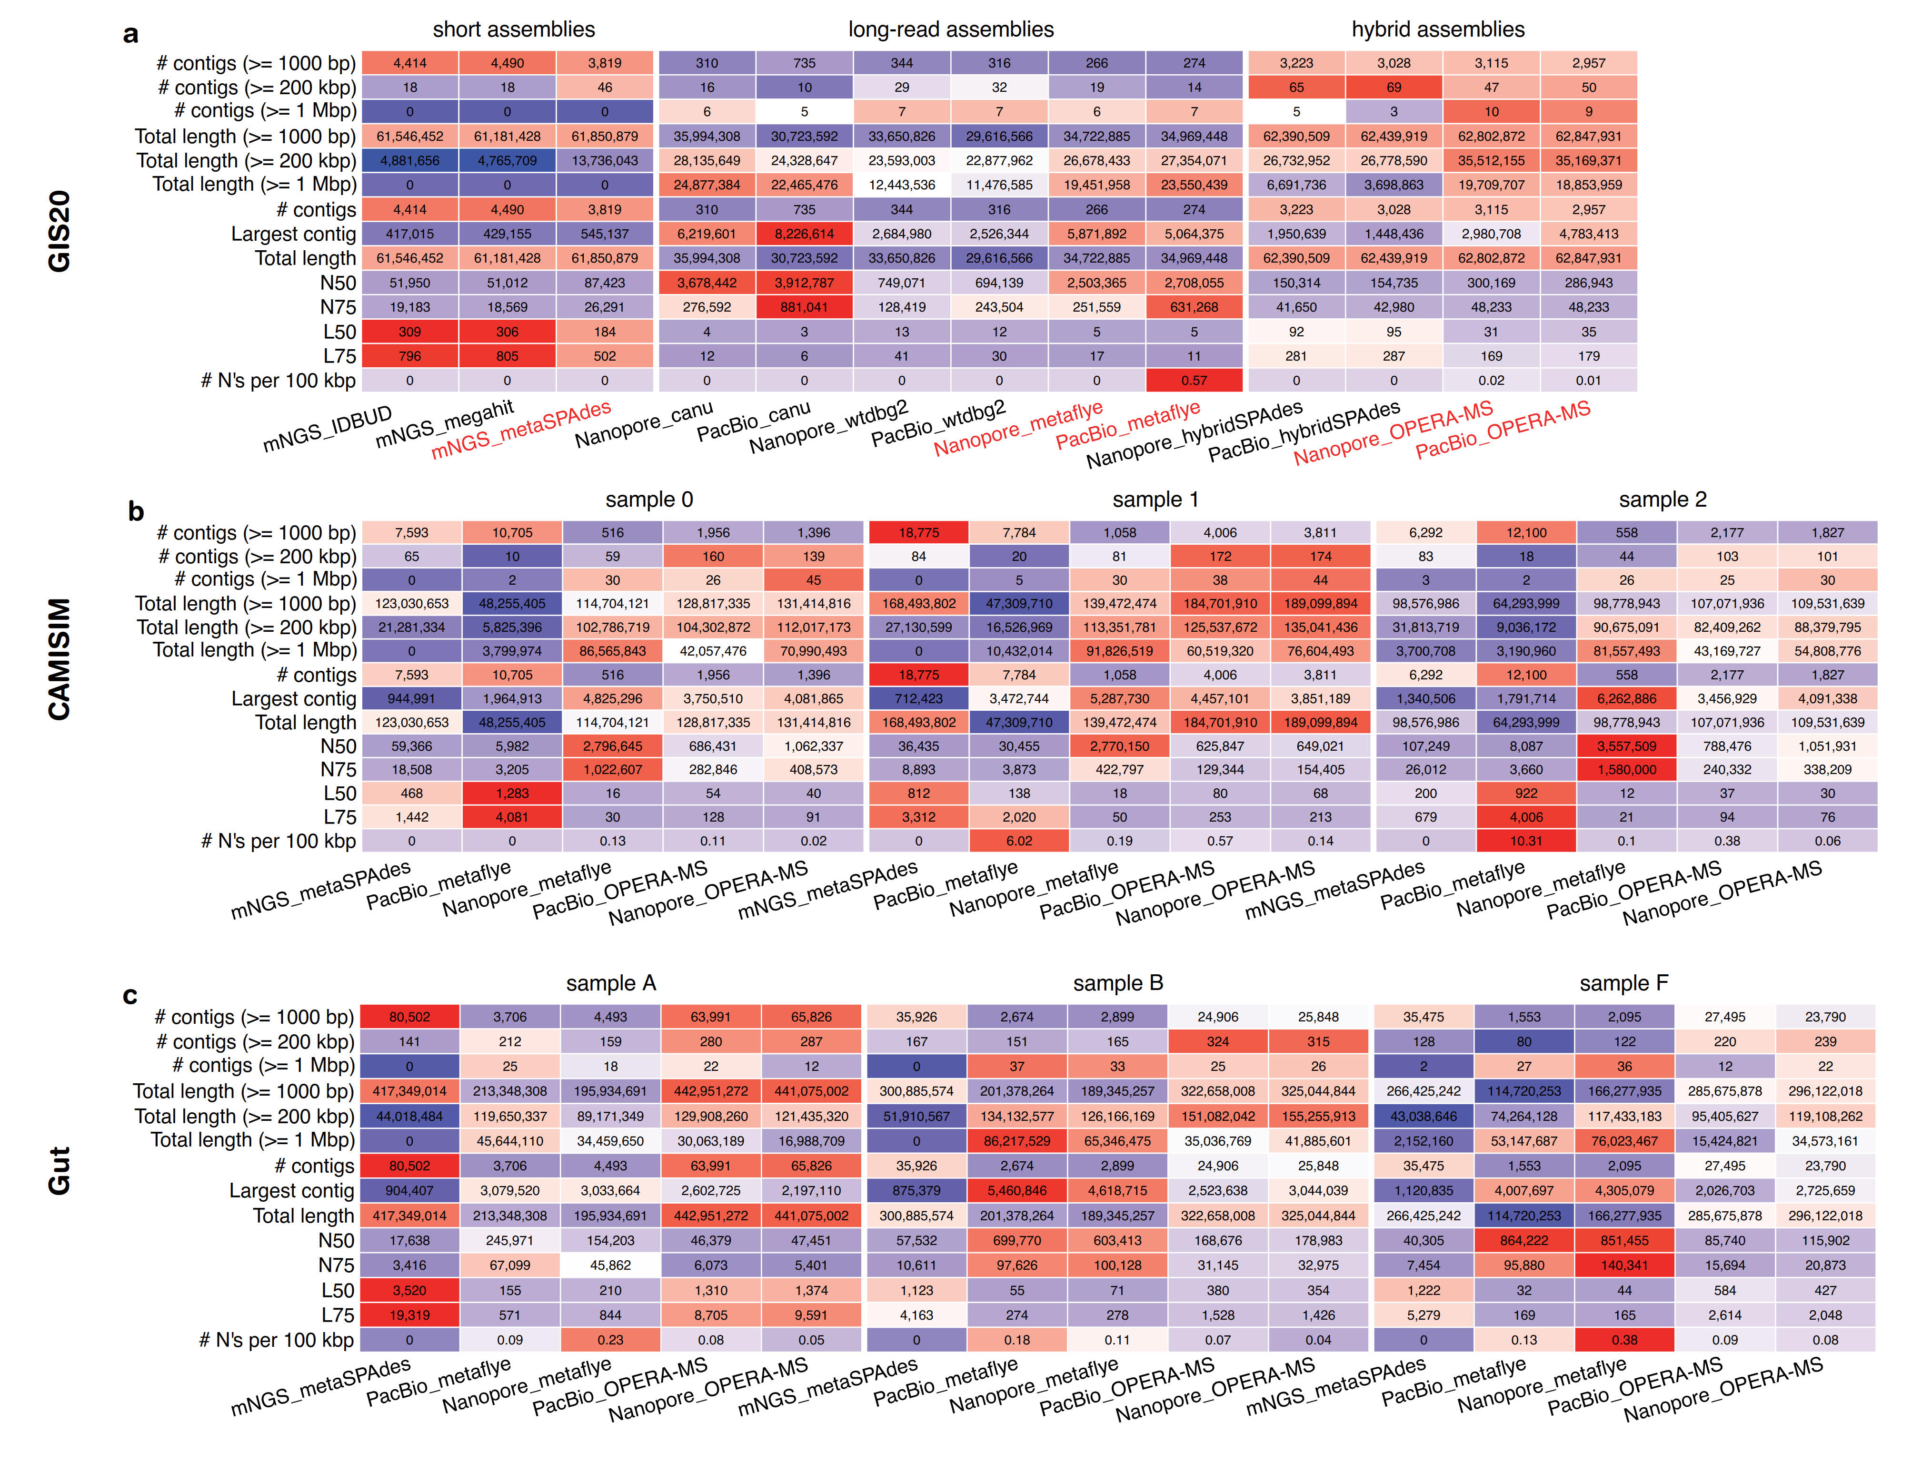 (a)** Evaluation of metagenomic assemblies from eight assemblers, including three short-read assemblers (IDBA-UD, MEGAHIT and metaSPAdes), three long-read assemblers (Canu, wtdbg2 and metaFlye) and two hybrid assemblers (hybridSPAdes and OPREA-MS) in the GIS20 datasets. **(b)** Evaluation of metagenomic assemblies from short-, long-read and hybrid assemblers in the three samples of the CAMISIM dataset. **(c)** Evaluation of metagenomic assemblies from short-, long-read and hybrid assemblers in the three samples of the Gut dataset. Overall, the total length and number of contigs from short-read and hybrid assemblies were several times larger than that of long-read assemblies while long-read assemblies showed the highest N50, followed by hybrid assemblies, and short-read assemblies showed the lowest N50.

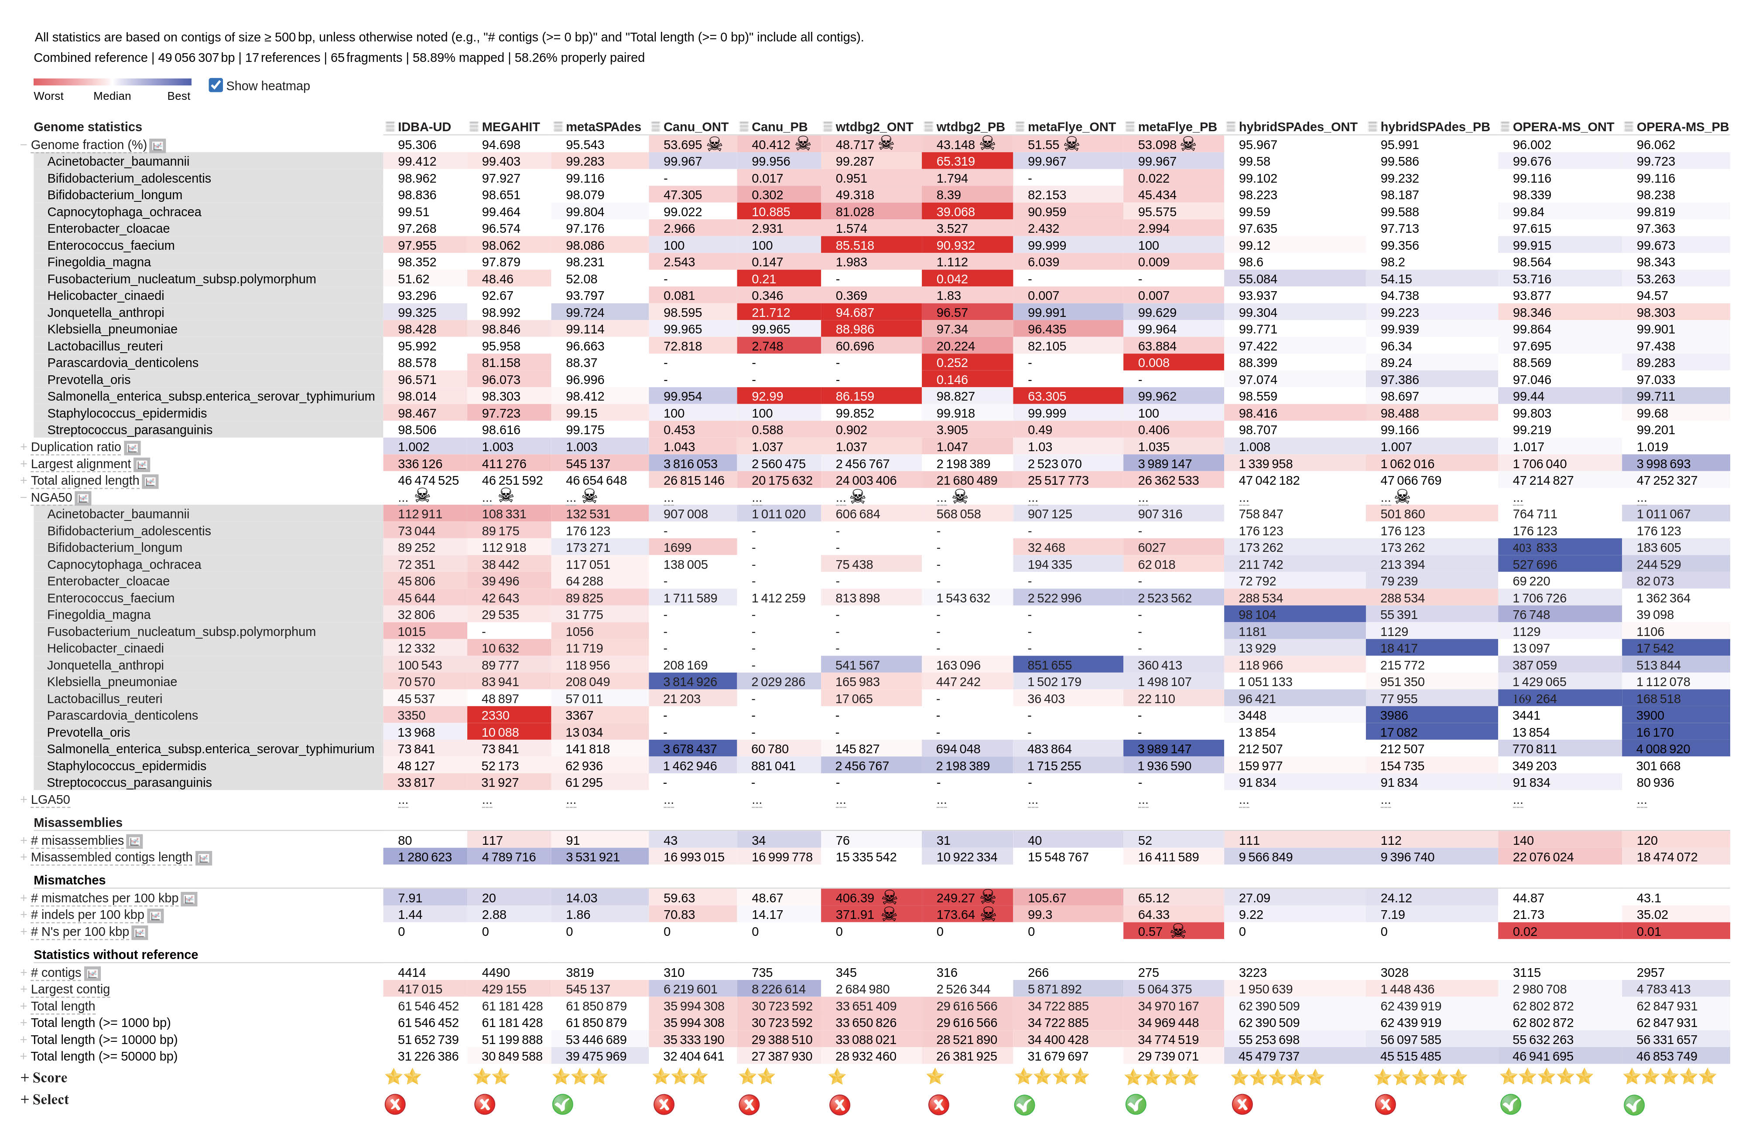**Figure S3. Evaluation of different assemblers on the GIS20 mock dataset using MetaQUAST.** Sequencing reads from mNGS, PacBio, and Nanopore were assembled by short-read assemblers, long-read assemblers, and hybrid assemblers. The performance of the assembly results was measured by genome factions (%), NGA50, misassemblies and mismatches, then scored thirteen assembly strategies across eight assemblers accordingly; the performance was indicated using the background color gradient from red to blue, with blue(red) indicating preferred(unpreferred) results; terrible results were marked by a skull. Based on these evaluations, metaSPAdes, metaFlye, and OPERA-MS were selected as the best assemblers for the short-read, long-read, and hybrid assemblies, respectively, and were marked with a green ‘check’ symbol; the others were marked with a red ‘cross’ symbol.

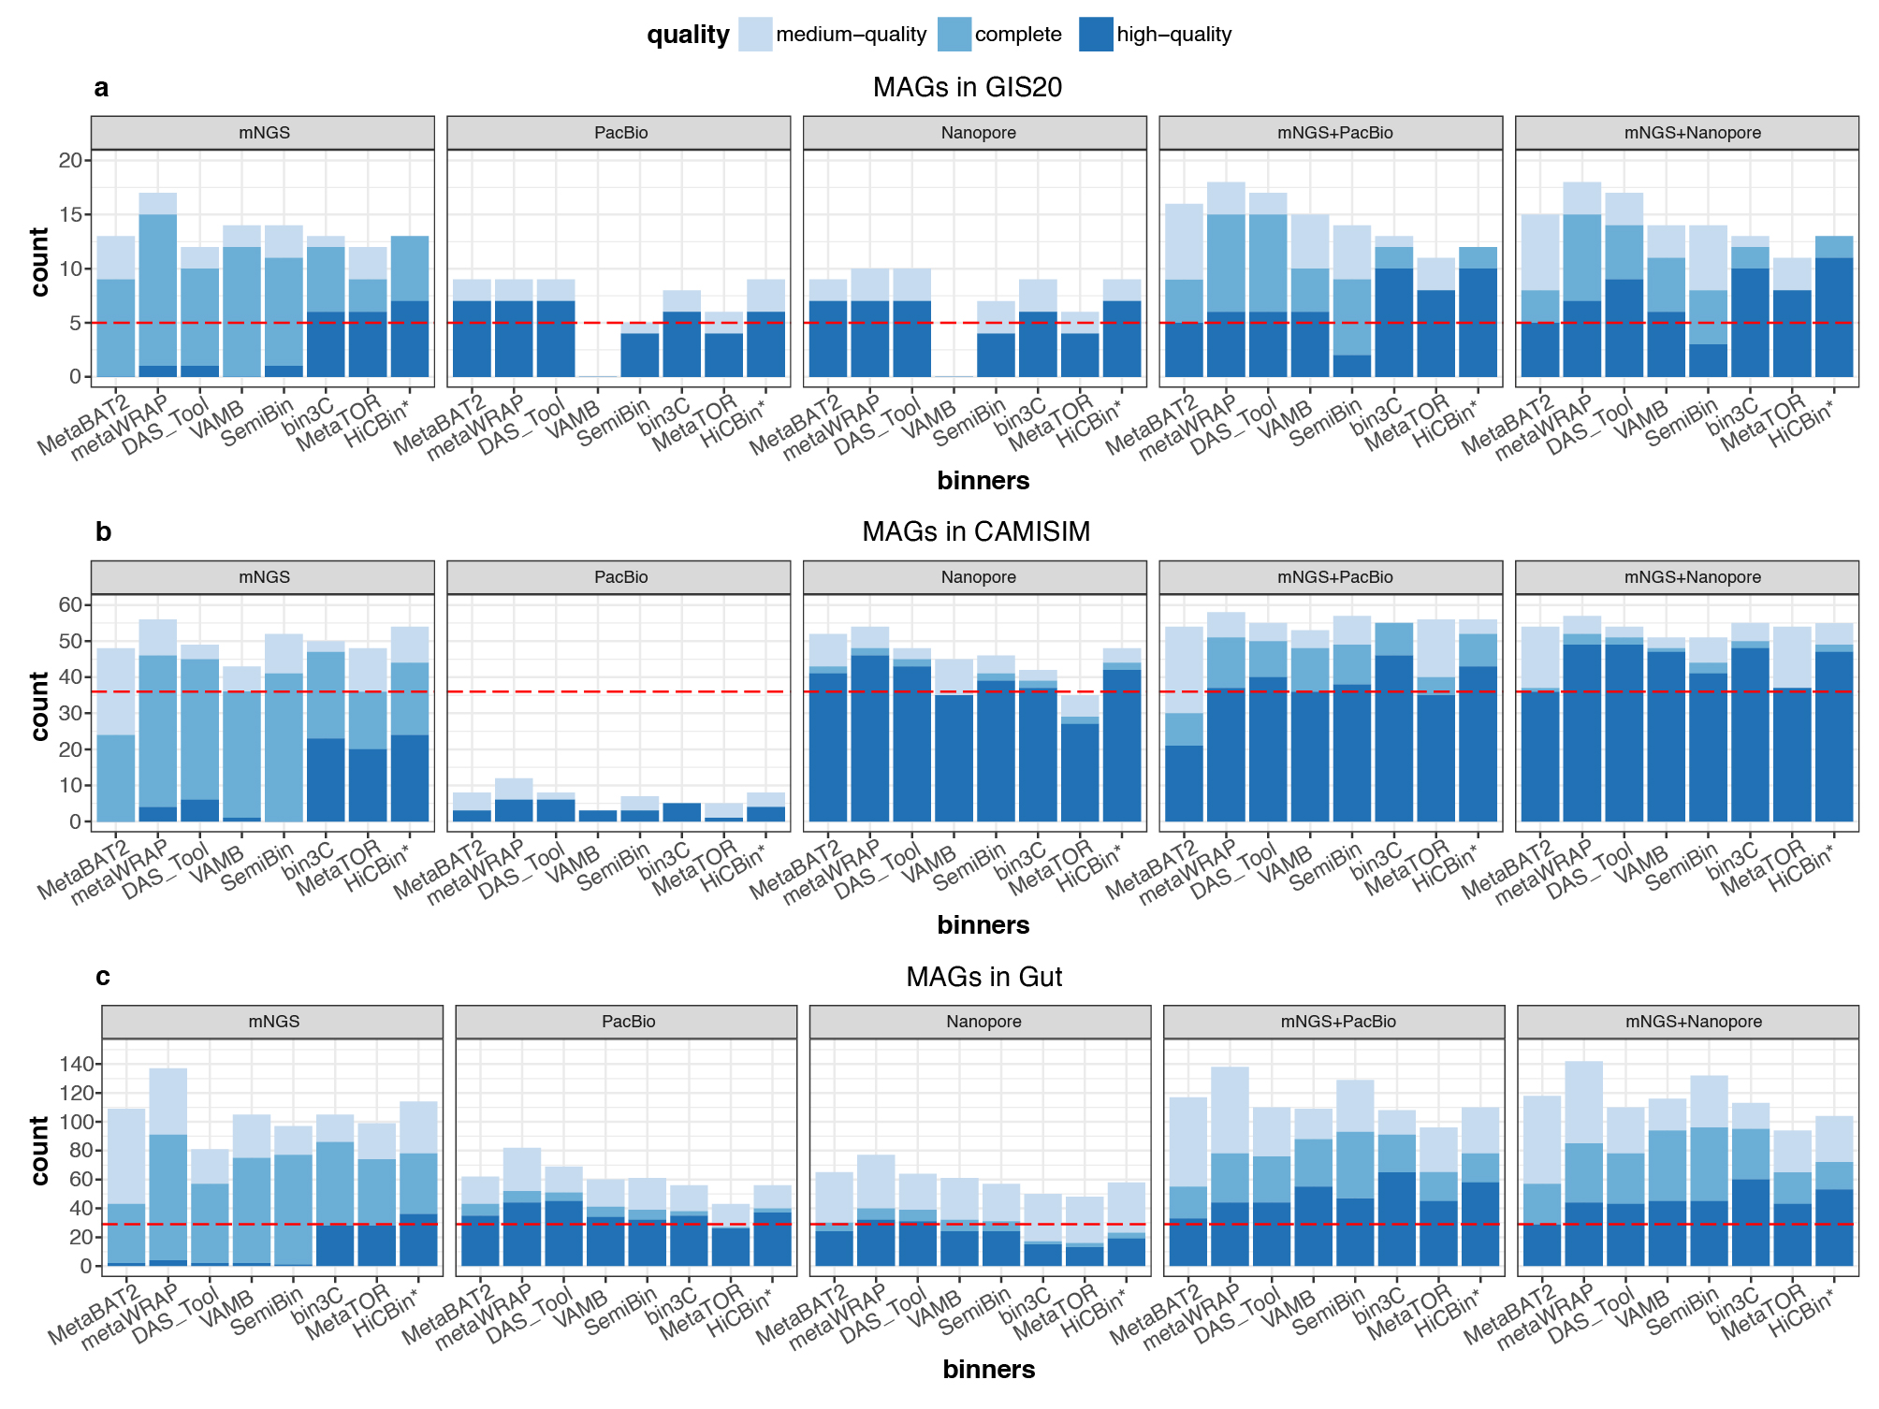**Figure S4. The number of dereplicated MAGs from the GIS20, CAMISIM and Gut datasets.** MAGs from each of the 40 strategies on the **(a)** GIS20, **(b)** CAMISIM and **(c)** Gut datasets were dereplicated by dRep. Hybrid assemblies combined with metaHiC-based binning provided the highest number of high-quality MAGs (>90% completeness, < 5% contamination, the presence of 5S, 16S, and 23S rRNA genes as well as 18 tRNA genes). The simulated Nanopore reads recovered more high-quality MAGs than the simulated PacBio reads because the latter has a lower quality score per base in the CAMISIM dataset. The PacBio high fidelity (HiFi) sequencing outperformed Nanopore sequencing due to a higher quality score per base in the Gut dataset.

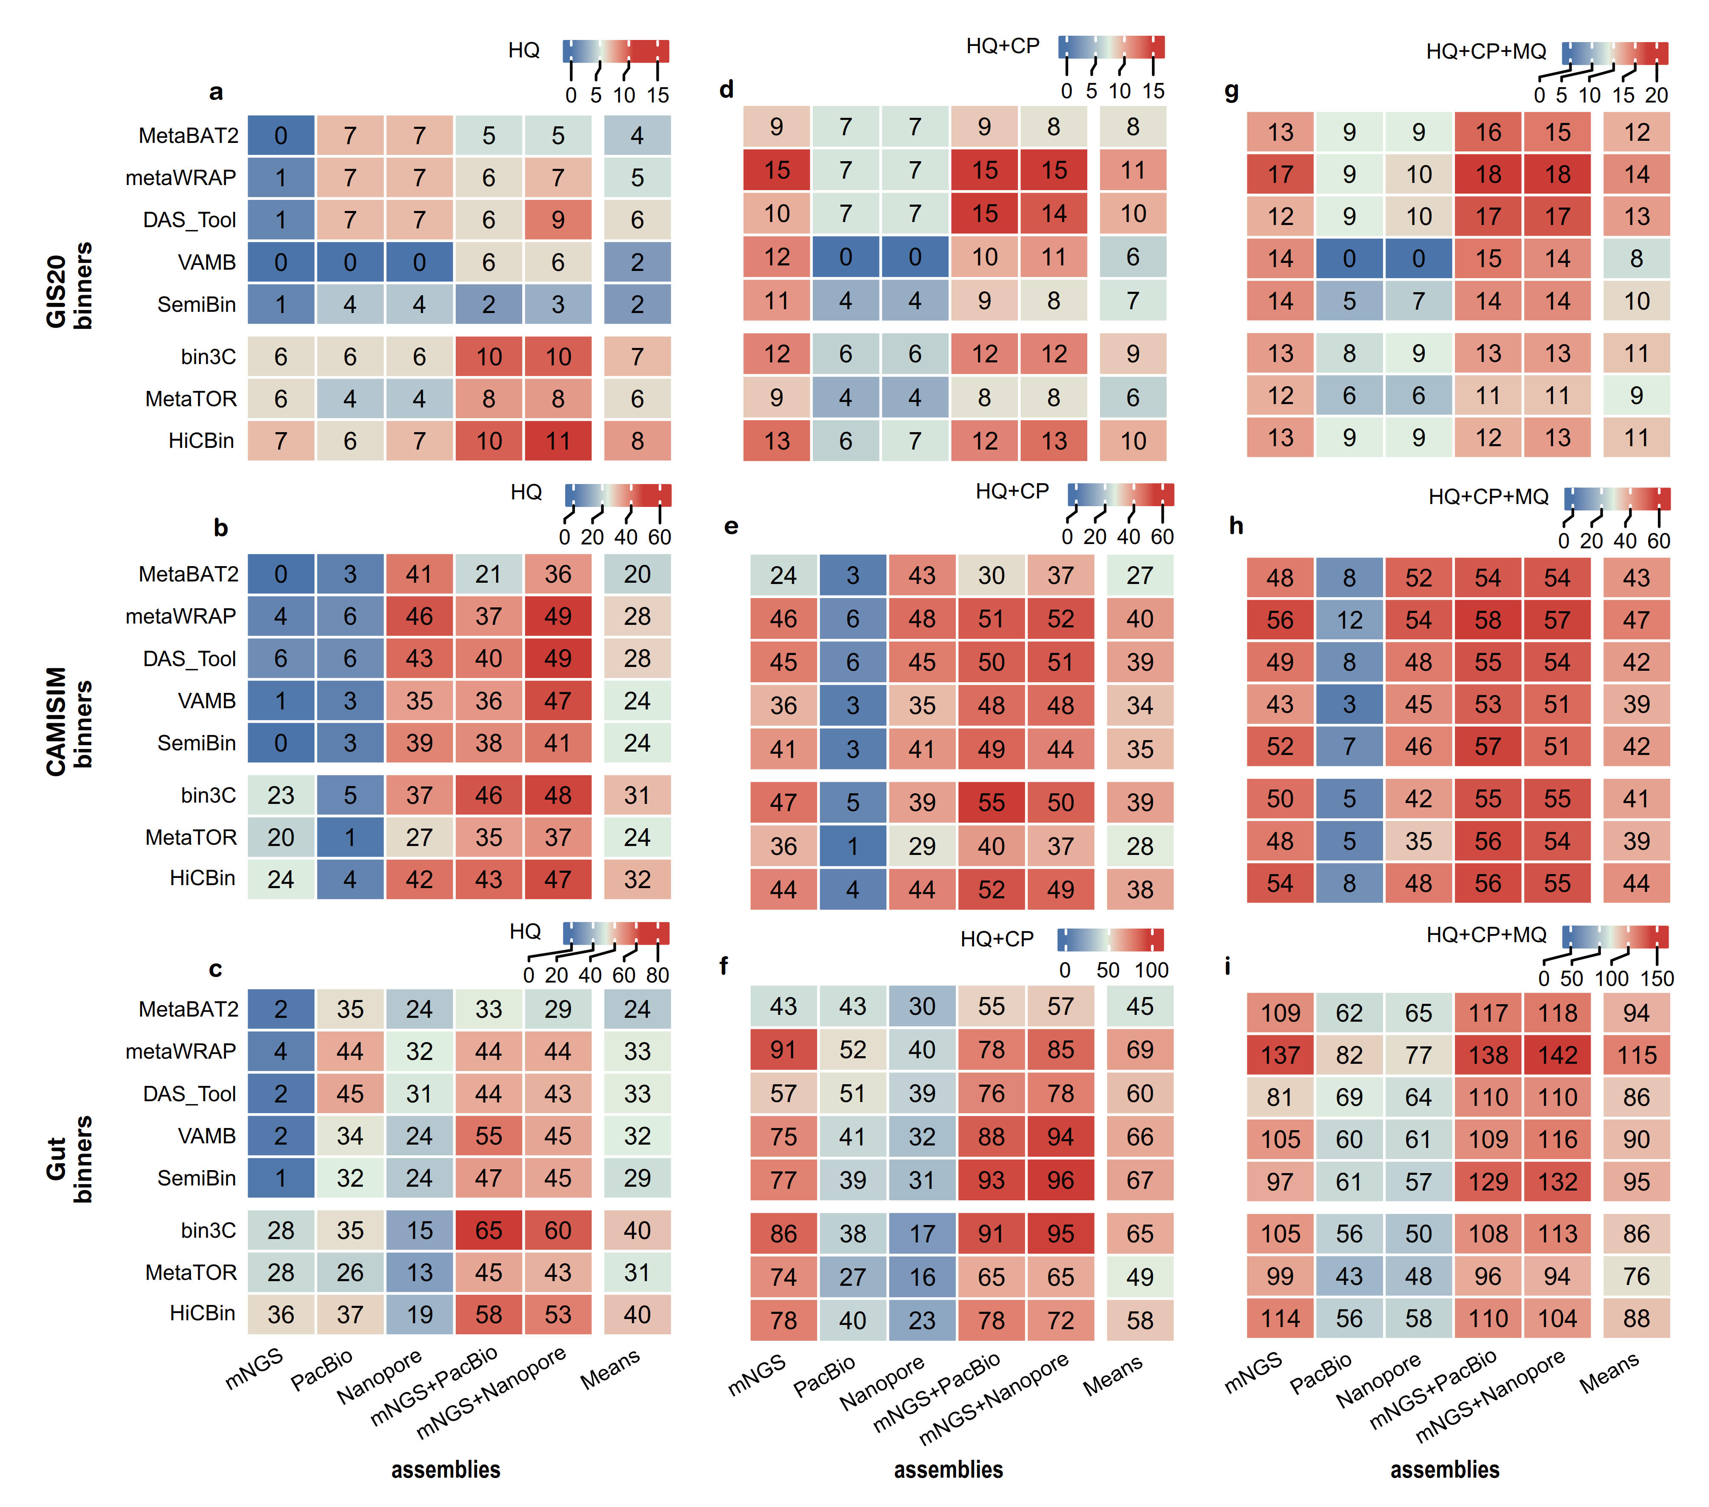

**Figure S5. The number of dereplicated high-quality (HQ), complete (CP) and medium-quality (MQ) MAGs from the GIS20, CAMISIM and Gut datasets.** The number of dereplicated MAGs from the GIS20, CAMISIM and Gut datasets with different quality levels, such as **(a-c)** high-qaulity (HQ, >90% completeness and < 5% contamination with the presence of the 5S, 16S, and 23S rRNA genes and at least 18 tRNA genes), **(d-f)** complete (CP, >90% completeness and < 5% contamination), and (g-i) medium-quality (MQ, ≥50% completeness and <10% contamination). Under more relaxed criteria, short-read assemblies recover much more complete or medium-quality MAGs while long-read assemblies do not increase complete or medium-quality MAGs dramatically. MAGs from fragemented short-read assemblies can hardly contain rRNA genes even with >90% completeness, while long-read assemblies can hardly cover low-abundance species.

**Figure S6. Per base sequence quality of PacBio versus Nanopore reads on the CAMISIM simulated dataset. (a)** The quality scores for simulated PacBio reads in the CAMISIM simulated dataset are between six and twelve. **(b)** The quality scores are around nine for simulated Nanopore reads in the CAMISIM simulated dataset. The simulated PacBio reads and long-read assembly produced less high-quality MAGs than those from the simulated Nanopore reads.

**Figure S7. Per base sequence quality of PacBio HiFi versus Nanopore reads in the Gut dataset. (a)** The quality scores of PacBio HiFi reads are over sixty in the Gut dataset. **(b)** The quality scores of Nanopore reads are between ten to twenty-five. The PacBio HiFi reads and long-read assemblies produced more high-quality MAGs than those from Nanopore reads.

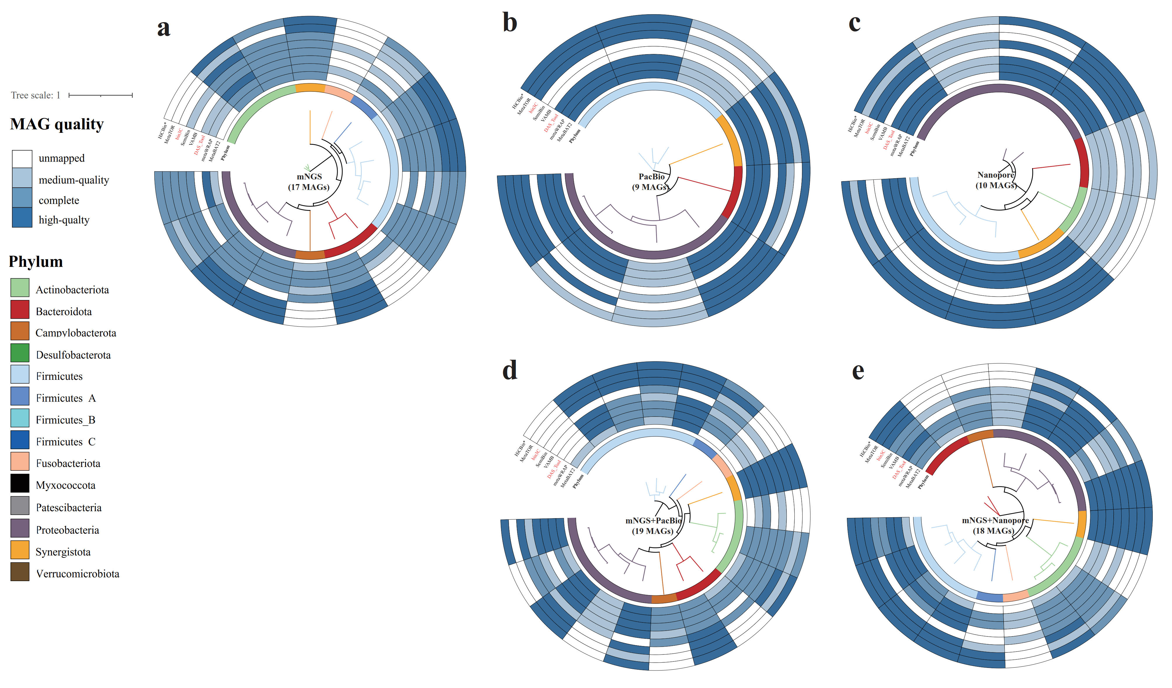**Figure S8**. **Dendrogram comparison of MAGs from different strategies in the GIS20 dataset.** The medium-quality, complete and high-quality MAGs from the (a) mNGS, (b) PacBio, (c) Nanopore, (d) mNGS+PacBio and (e) mNGS+Nanopore assemblies combined with similarity-based (MetaBAT2, metaWRAP, DAS_Tool, VAMB and SemiBin) and metaHiC-based (bin3C, MetaTOR and HiCBin) binners. The colour of the inner phylogenetic tree and circle show the phyla. The heat maps of the outer circle show the quality of MAGs on the corresponding phylogenetic branches. The hybrid assemblies combined with metaHiC-based binning recovered more high-quality MAGs than other strategies.

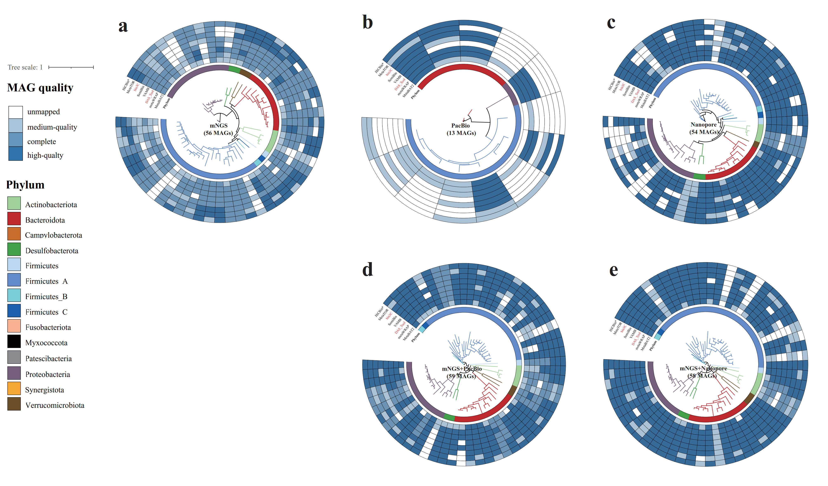

**Figure S9**. **Dendrogram comparison of MAGs from different strategies in the CAMISIM dataset.** The medium-quality, complete and high-quality MAGs from the (a) mNGS, (b) PacBio, (c) Nanopore, (d) mNGS+PacBio and (e) mNGS+Nanopore assemblies combined with similarity-based (MetaBAT2, metaWRAP, DAS_Tool, VAMB and SemiBin) and metaHiC-based (bin3C, MetaTOR and HiCBin) binners. The color of the inner phylogenetic tree and circle show the phyla. The heat maps of the outer circle show the quality of MAGs on the corresponding phylogenetic branches. The hybrid assemblies combined with metaHiC-based binning recovered more high-quality MAGs.

**Figure S10**. **Dendrogram comparison of MAGs from different strategies in the Gut dataset.** The medium-quality, complete and high-quality MAGs from the (a) mNGS, (b) PacBio, (c) Nanopore, (d) mNGS+PacBio and (e) mNGS+Nanopore assemblies combined with similarity-based (MetaBAT2, metaWRAP, DAS_Tool, VAMB and SemiBin) and metaHiC-based (bin3C, MetaTOR and HiCBin) binners. The colour of the inner phylogenetic tree and circle show the phyla. The heat maps of the outer circle show the quality of MAGs on the corresponding phylogenetic branches. The hybrid assemblies combined with metaHiC-based binning recovered more high-quality MAGs than other strategies. 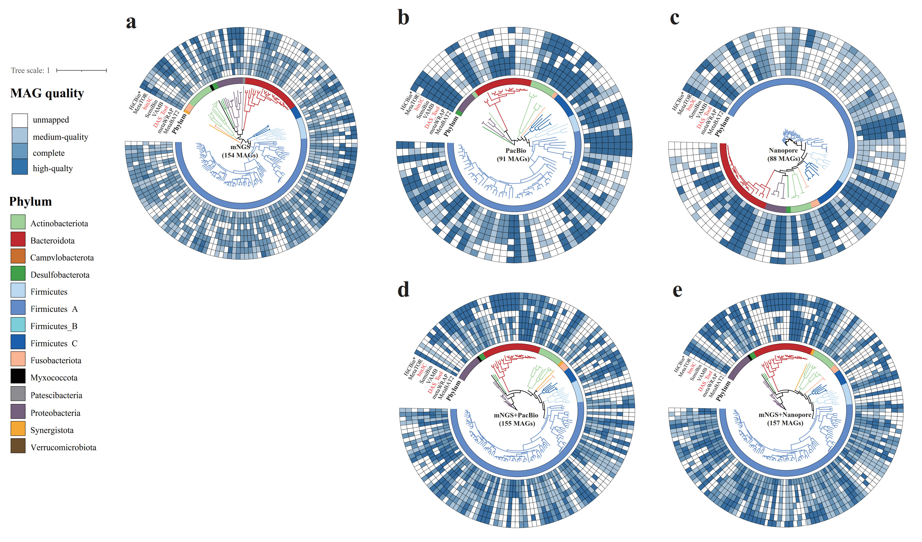

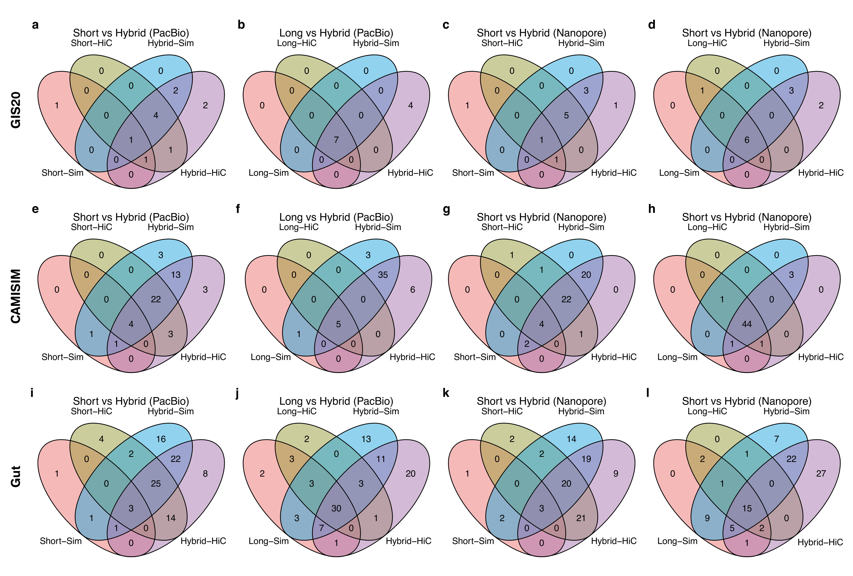

**Figure S11. Comparison of species from different strategies.** For high-quality MAGs from different species, we compared their species between short-read and hybrid assemblies, and between long-read and hybrid assemblies in the **(a-d)** GIS20, **(e-h)** CAMISIM and **(i-l)** Gut datasets. The results suggest that the hybrid assembly strategies recovered more distinct microbial species than the short- or long-read strategies.

**Figure S12. Comparison of species in the *Bacteroidota* phylum from different strategies.** For high-quality MAGs from different species, we compared their species between short-read and hybrid assemblies, and between long-read and hybrid assemblies in the **(a-d)** GIS20, **(e-h)** CAMISIM and **(i-l)** Gut datasets. The results suggest that the hybrid assembly strategies recovered more distinct microbial species in the *Bacteroidota* phylum than the short- or long-read strategies.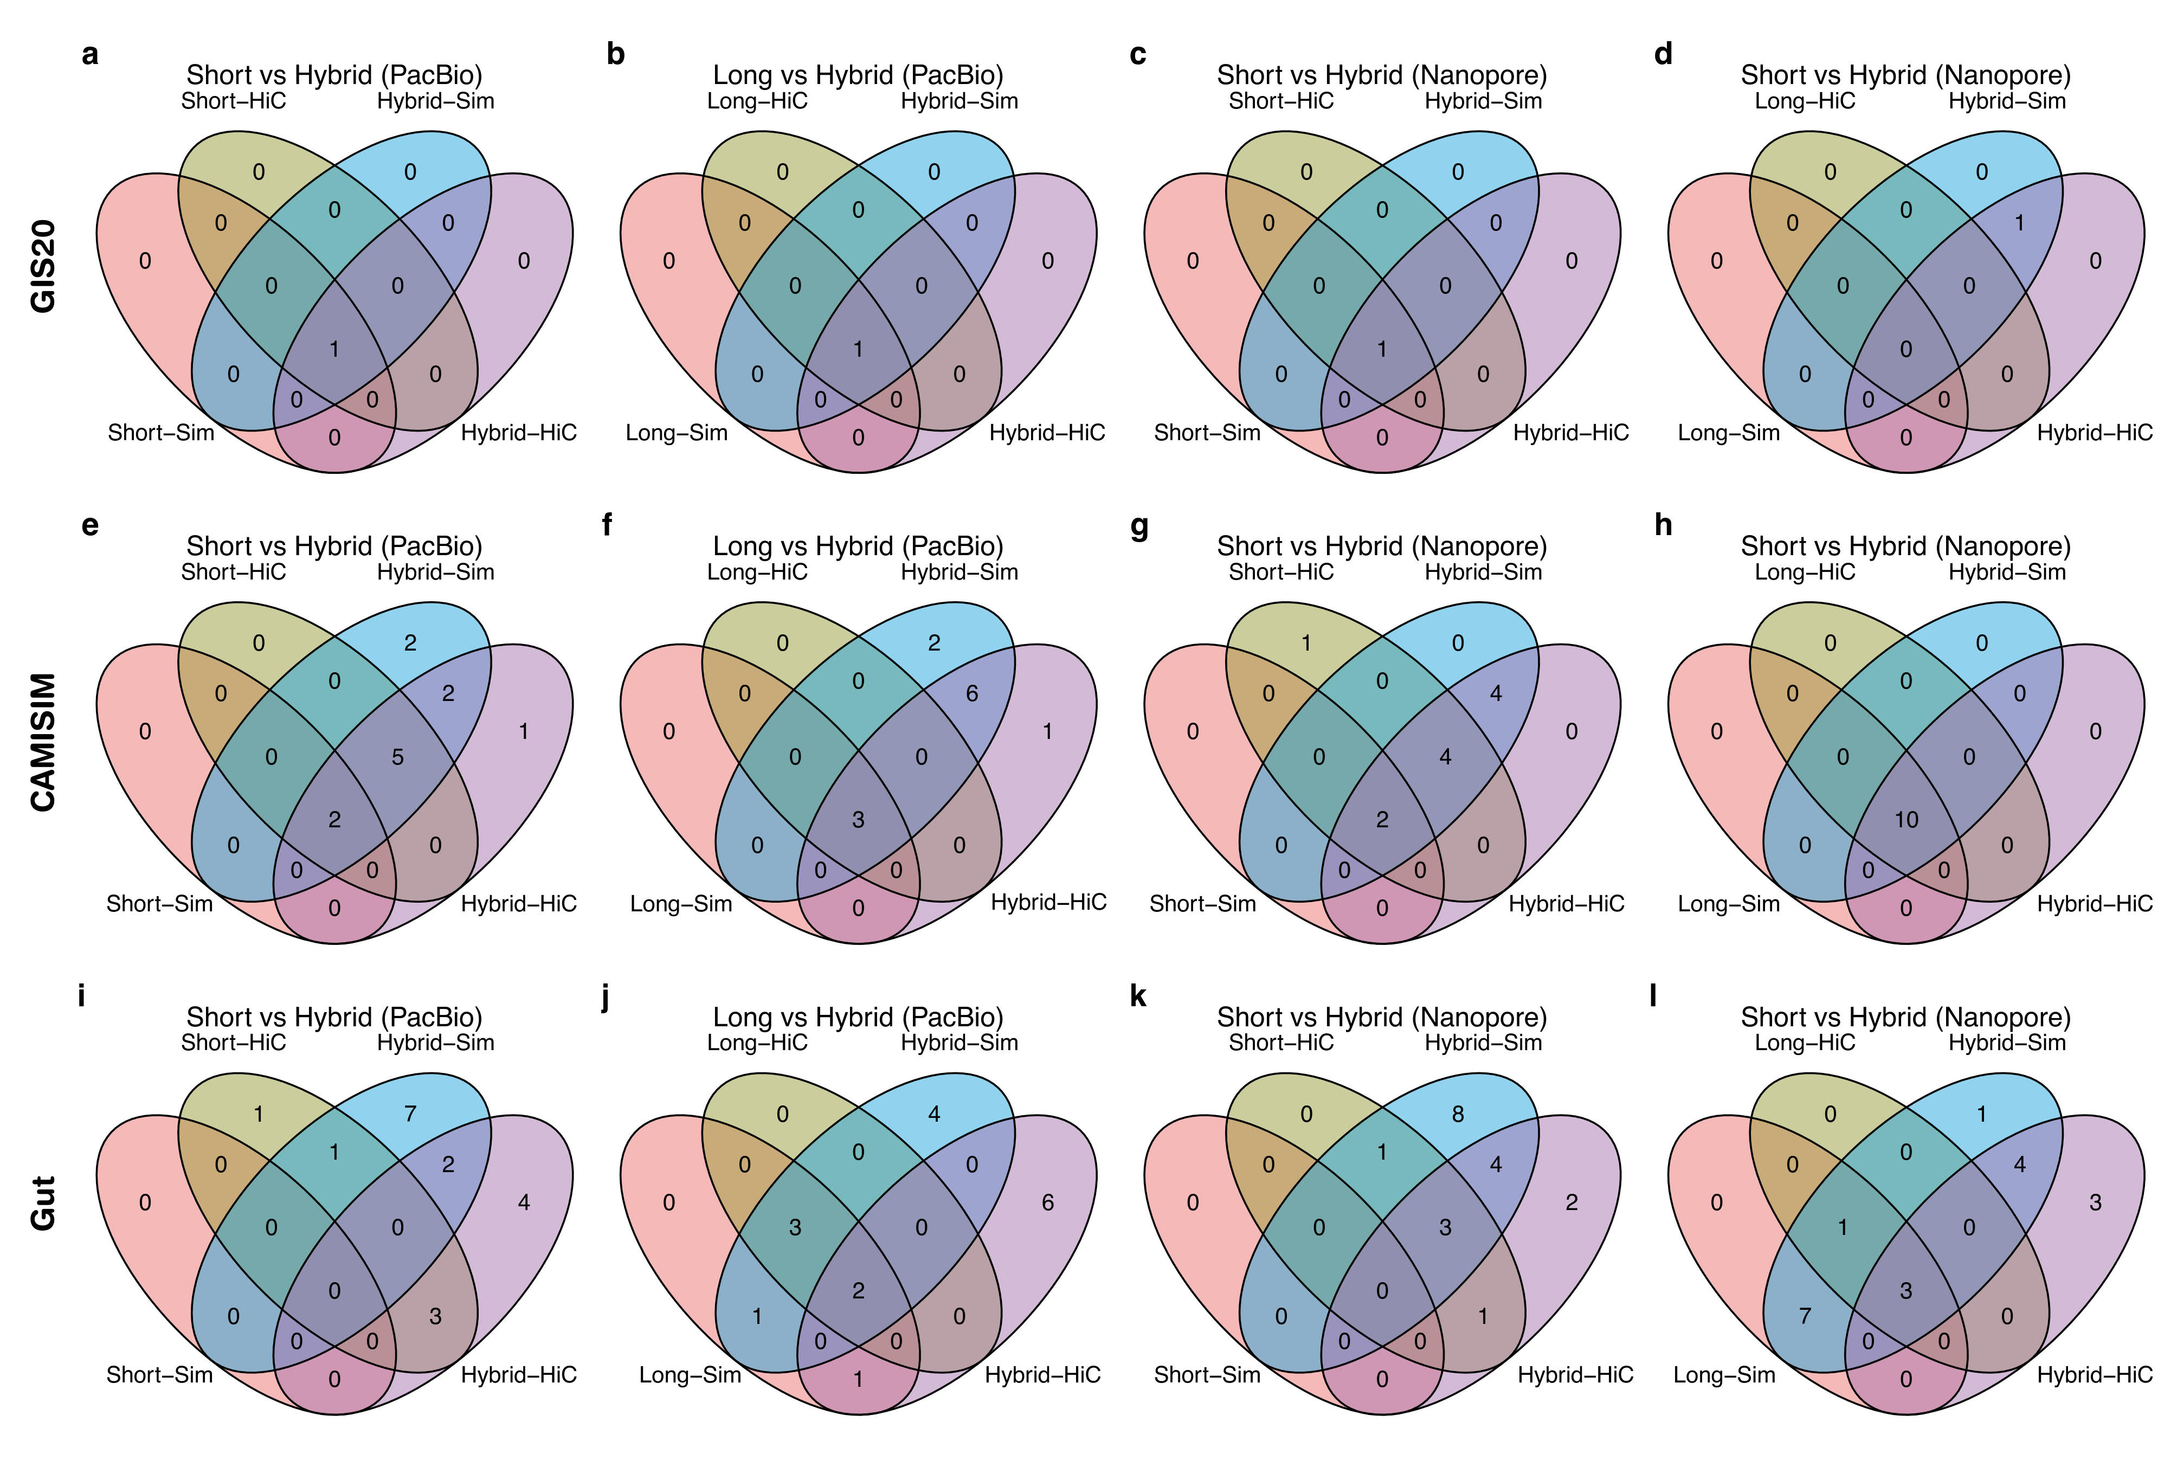

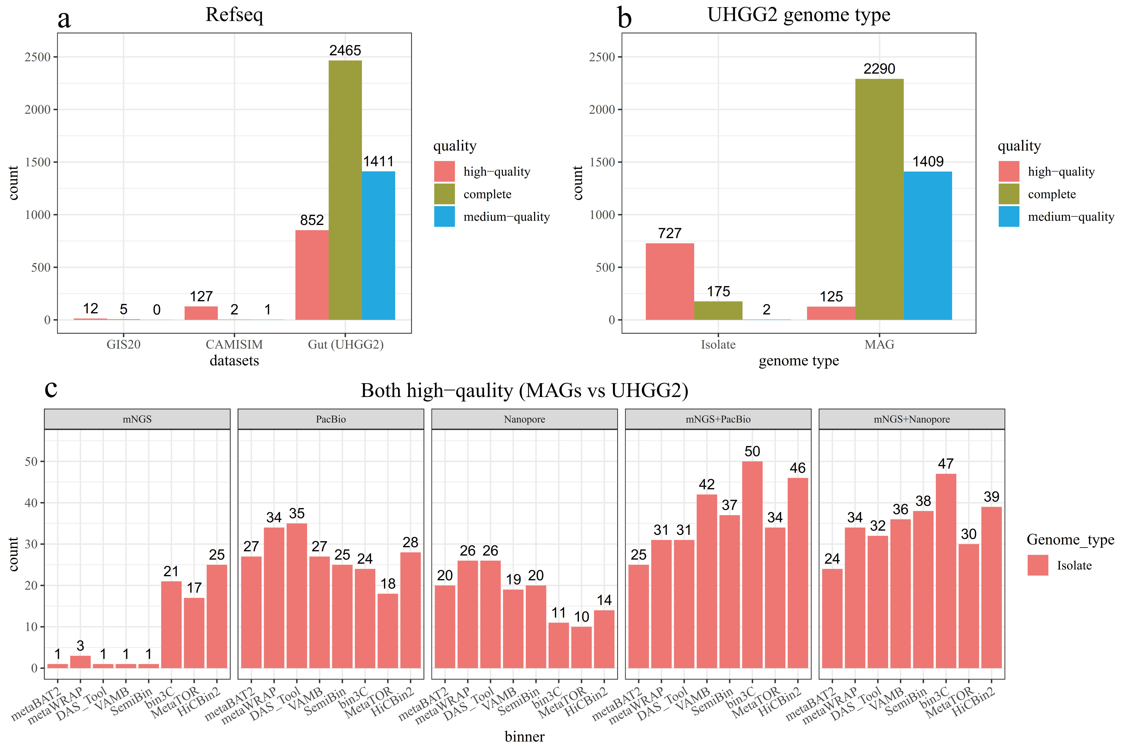**Figure S13. The quality of reference genomes for the GIS20, CAMISIM and Gut dataset.** (a) The reference genomes for the GIS20 (17 genomes), CAMISIM (130 genomes) and Gut (4728 genomes) datasets. (b) The 4728 reference genomes in UHGG2 are derived from isolated (904 genomes, 19.1%) or MAG (3824 genomes, 80.9%). 80.4% (727/904) reference genomes from isolate are high-quality, while 3.3% (125/3824) reference genomes from MAG are high-quality. (c) When high-quality MAGs were mapped to high-quality reference genomes, we checked the source and found that almost all high-quality reference genomes were isolated.

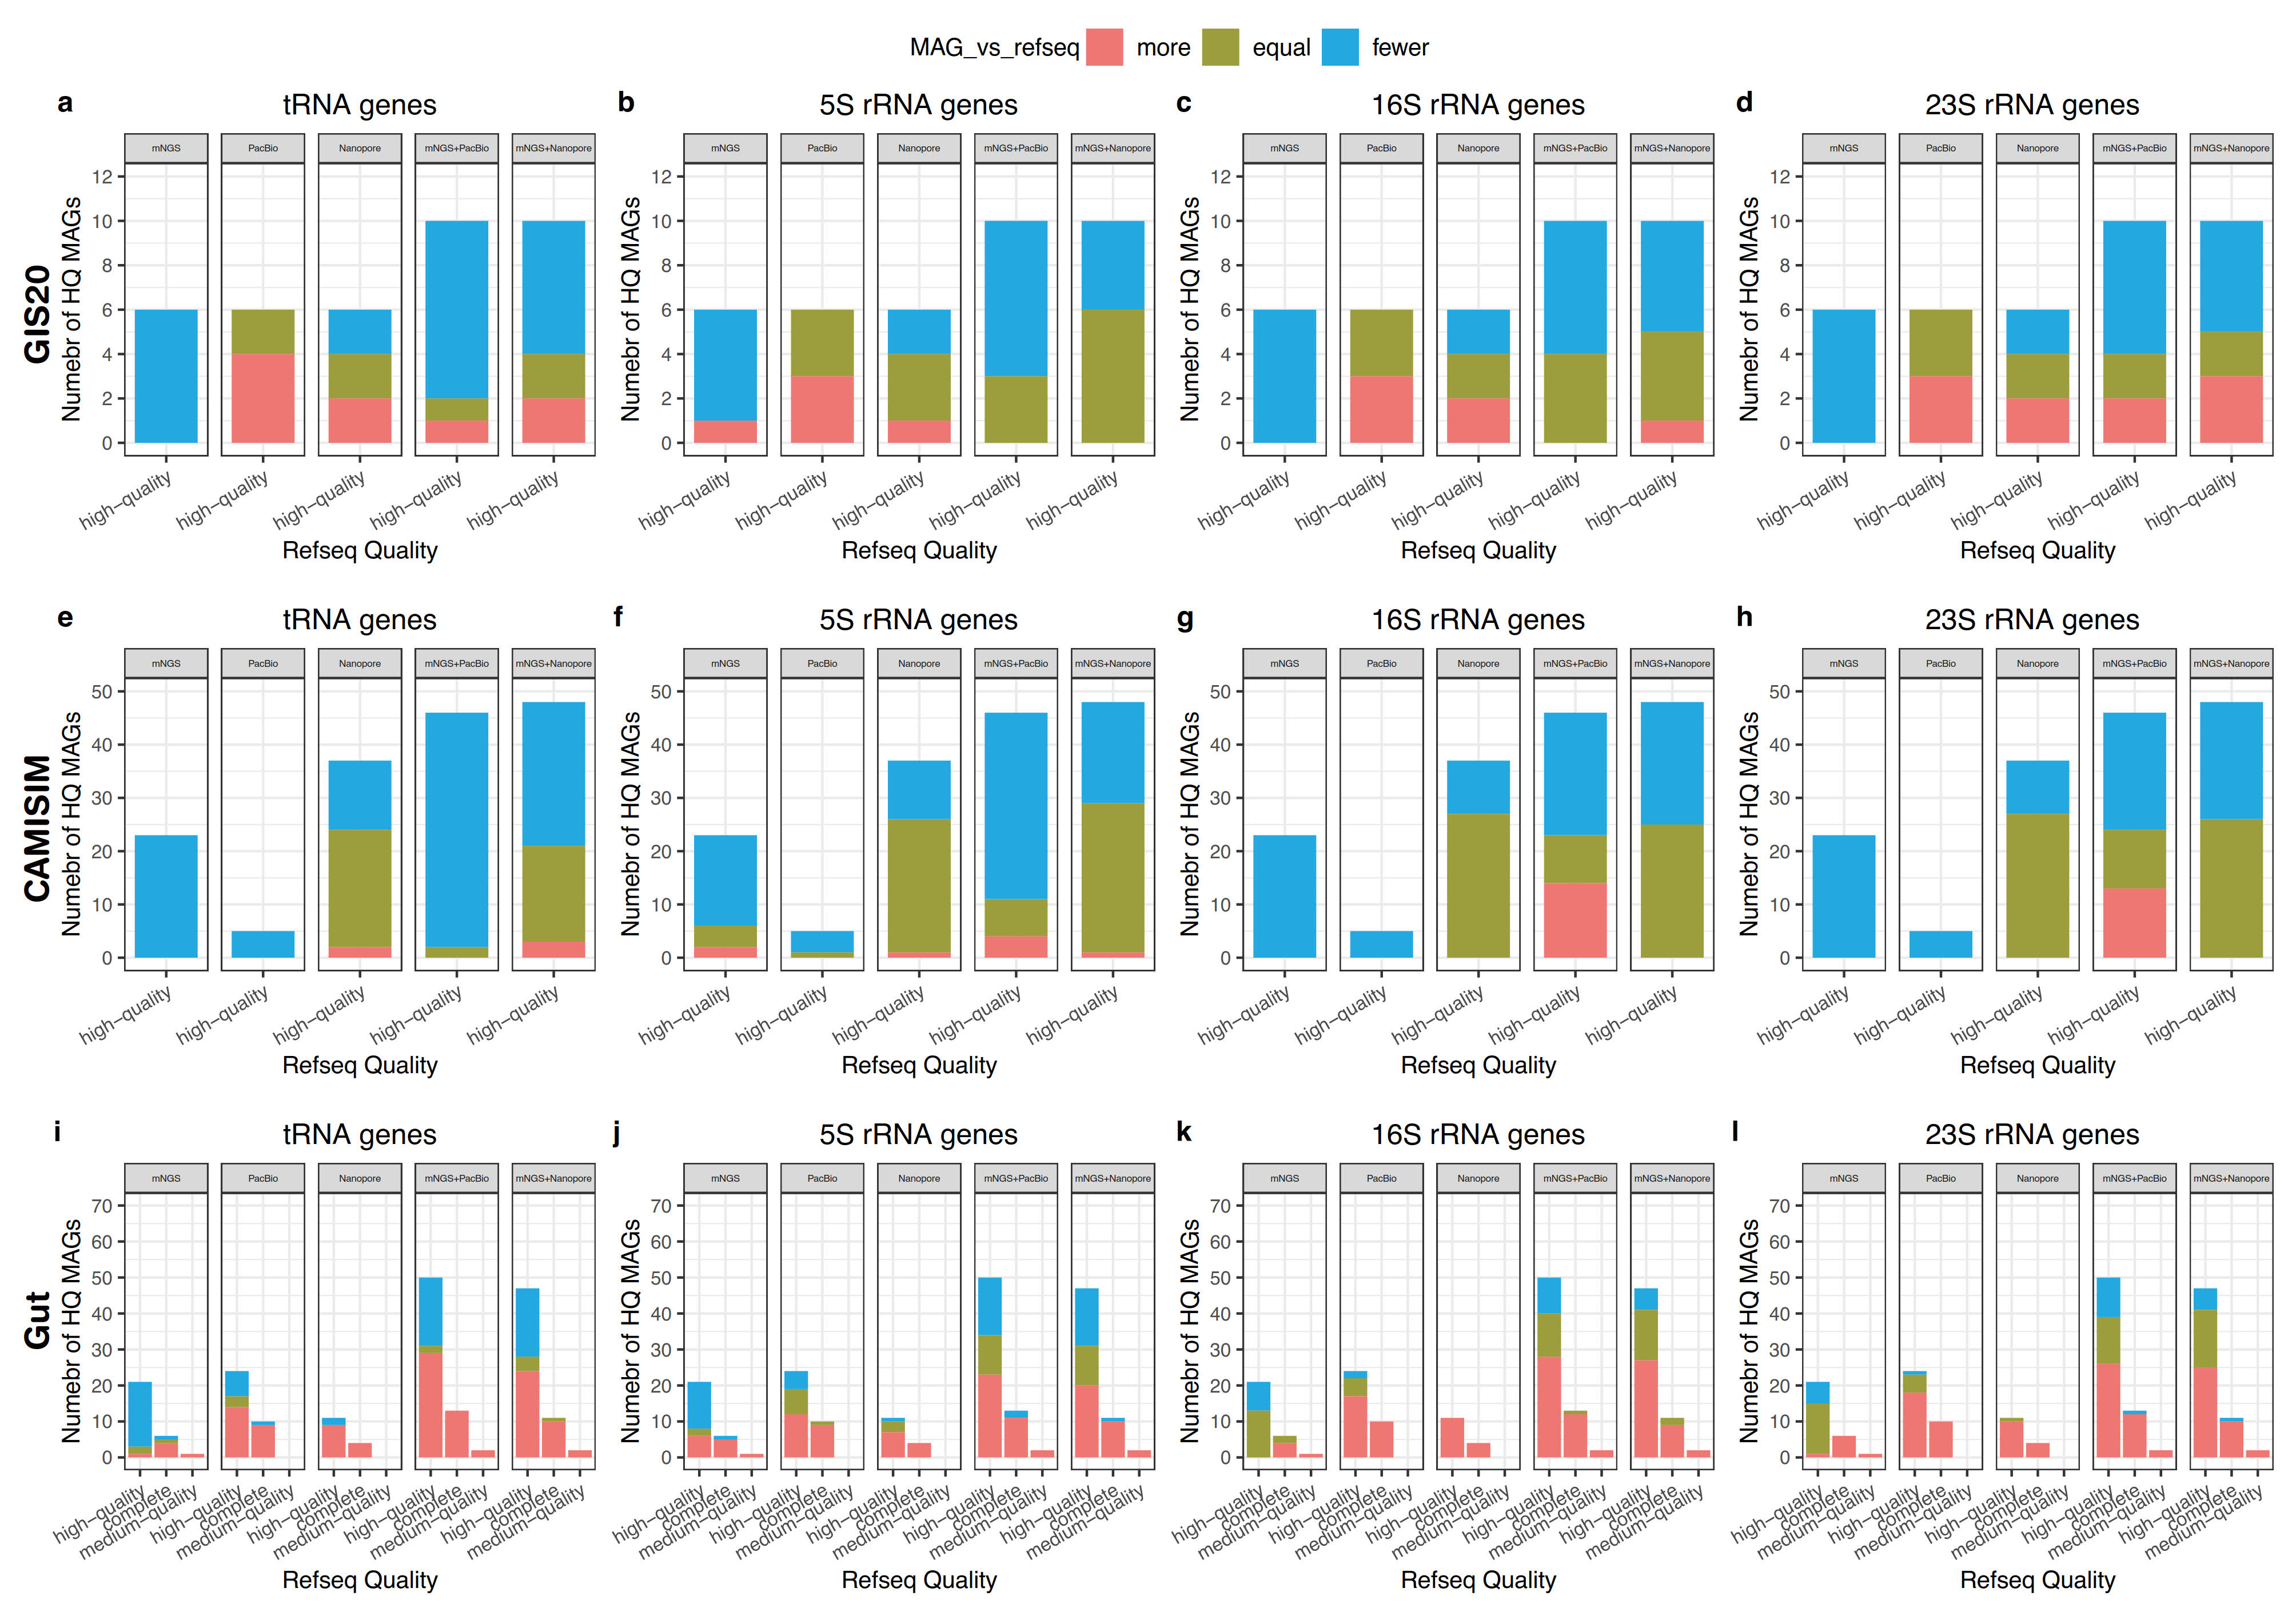**Figure S14. Assessment of the impact of reference genome quality on the relative number of tRNA and rRNA genes in the HQ-MAGs and reference genomes.** The number of tRNA genes and 5S, 16S, and 23S rRNA genes in HQ-MAGs may be more than, equal to, or less than that of reference genomes in the **(a)** GIS20, **(b)** CAMISIM and **(c)** Gut datasets. All HQ-MAGs from the GIS20 and CAMISIM datasets were mapped to high-quality reference genomes while around 30% of HQ-MAGs were mapped to complete or medium-quality reference genomes. For high-quality reference genomes, HQ-MAGs from short-read assemblies could hardly contain more tRNA and rRNA genes than reference genomes while around 50% of MAGs from long-read or hybrid assemblies contained more tRNA and rRNA genes than reference genomes. For complete or medium-quality of reference genomes, almost all HQ-MAGs contained more tRNA and rRNA genes than their reference genomes.

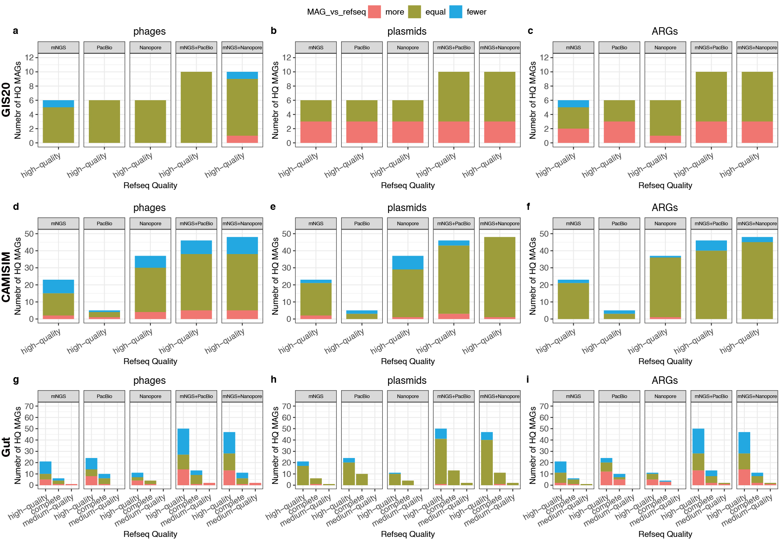**Figure S15. Assessment of the impact of reference genome quality on the relative number of phages, plasmids, and antibiotic resistance genes (ARGs) in the HQ-MAGs and reference genomes.** The number of phages, plasmids, and ARGs in HQ-MAGs may be more than, equal to, or less than that of reference genomes in the **(a)** GIS20, **(b)** CAMISIM and **(c)** Gut datasets. All HQ-MAGs from the GIS20 and CAMISIM datasets were mapped to high-quality reference genomes while around 30% of HQ-MAGs were mapped to complete or medium-quality reference genomes. For high-quality reference genomes, only a few HQ-MAGs from short-read assemblies contained more phages, plasmids, and ARGs than reference genomes, while more HQ-MAGs from long-read and hybrid assemblies contained more phages, plasmids, and ARGs than their reference genomes. For complete or medium-quality of reference genomes, 80% of HQ-MAGs still contained the same or fewer phages, plasmids, and ARGs than their reference genomes. Therefore, the hybrid-HiC strategy recovered more HQ-MAGs with more phages, plasmids, and ARGs than their reference genomes, likely due to metaHiC-based binning rather than the poor-quality reference genomes.

## **Supplementary Table Guide**

**Supplementary Table S1.** The GIS20 mock dataset composition.

**Supplementary Table S2-1.** The sample0 composition in the CAMISIM simulated dataset.

**Supplementary Table S2-2.** The sample1 composition in the CAMISIM simulated dataset.

**Supplementary Table S2-3.** The sample2 composition in the CAMISIM simulated dataset.

**Supplementary Table S4.** Comparison of metagenomic next-generation sequencing (mNGS) , PacBio HiFi, Nanopore, and metagenomic high-throughput chromosomal conformation capture(metaHiC).

**Supplementary Table S4**. The read-length statistic of ‘clean-data’.

**Supplementary Table S5.** The comparison of PacBio subreads and HiFi reads in the Gut dataset.

**Supplementary Table S6.** The computational time and resources of metagenomic assemblers and binners.

**Supplementary Table S7.** The evaluation of metagenomic assemblies (i.e., genome fraction(%), NGA50, num misassemblies per Mbp, num mismatches per 100 kbp) by MetaQUAST.

**Table S8-1.** Evaluation of MAGs from the GIS20 dataset in terms of completeness, contamination, tRNA genes, and rRNA genes.

**Table S8-2.** Evaluation of MAGs from the CAMISIM dataset in terms of completeness, contamination, tRNA genes, and rRNA genes.

**Table S8-3.** Evaluation of MAGs from the Gut dataset in terms of completeness, contamination, tRNA genes, and rRNA genes.

**Table S9-1.** Comparison of the number of tRNA and rRNA genes, phages, plasmids, and ARGs in HQ-MAGs from the GIS20 dataset and their reference genomes.

**Table S9-2.** Comparison of the number of tRNA and rRNA genes, phages, plasmids, and ARGs in HQ-MAGs from the CAMISIM dataset and their reference genomes.

**Table S9-3.** Comparison of the number of tRNA and rRNA genes, phages, plasmids and ARGs in HQ-MAGs from the Gut dataset and their reference genomes.

## References

1. Chen LX, Anantharaman K, Shaiber A et al. Accurate and complete genomes from metagenomes, Genome Res 2020;30:315-333.

2. He C, Keren R, Whittaker ML et al. Genome-resolved metagenomics reveals site-specific diversity of episymbiotic CPR bacteria and DPANN archaea in groundwater ecosystems, Nat Microbiol 2021;6:354-365.

3. Lemos LN, Mendes LW, Baldrian P et al. Genome-Resolved Metagenomics Is Essential for Unlocking the Microbial Black Box of the Soil, Trends Microbiol 2021;29:279-282.

4. Kayani MUR, Huang W, Feng R et al. Genome-resolved metagenomics using environmental and clinical samples, Brief Bioinform 2021.

5. Bertrand D, Shaw J, Kalathiyappan M et al. Hybrid metagenomic assembly enables high-resolution analysis of resistance determinants and mobile elements in human microbiomes, Nat Biotechnol 2019;37:937-944.

6. DeMaere MZ, Darling AE. Sim3C: simulation of Hi-C and Meta3C proximity ligation sequencing technologies, Gigascience 2018;7:gix103.

7. Nissen JN, Johansen J, Allesoe RL et al. Improved metagenome binning and assembly using deep variational autoencoders, Nat Biotechnol 2021;39:555-560.

8. Mikheenko A, Saveliev V, Gurevich A. MetaQUAST: evaluation of metagenome assemblies, Bioinformatics 2016;32:1088-1090.

9. Bowers RM, Kyrpides NC, Stepanauskas R et al. Minimum information about a single amplified genome (MISAG) and a metagenome-assembled genome (MIMAG) of bacteria and archaea, Nat Biotechnol 2017;35:725-731.

10. Moss EL, Maghini DG, Bhatt AS. Complete, closed bacterial genomes from microbiomes using nanopore sequencing, Nat Biotechnol 2020;38:701-707.

11. Kuleshov V, Jiang C, Zhou W et al. Synthetic long-read sequencing reveals intraspecies diversity in the human microbiome, Nat Biotechnol 2016;34:64-69.

12. Bishara A, Moss EL, Kolmogorov M et al. High-quality genome sequences of uncultured microbes by assembly of read clouds, Nat Biotechnol 2018.

13. Guo J, Bolduc B, Zayed AA et al. VirSorter2: a multi-classifier, expert-guided approach to detect diverse DNA and RNA viruses, Microbiome 2021;9:37.

14. Nayfach S, Camargo AP, Schulz F et al. CheckV assesses the quality and completeness of metagenome-assembled viral genomes, Nat Biotechnol 2021;39:578-585.